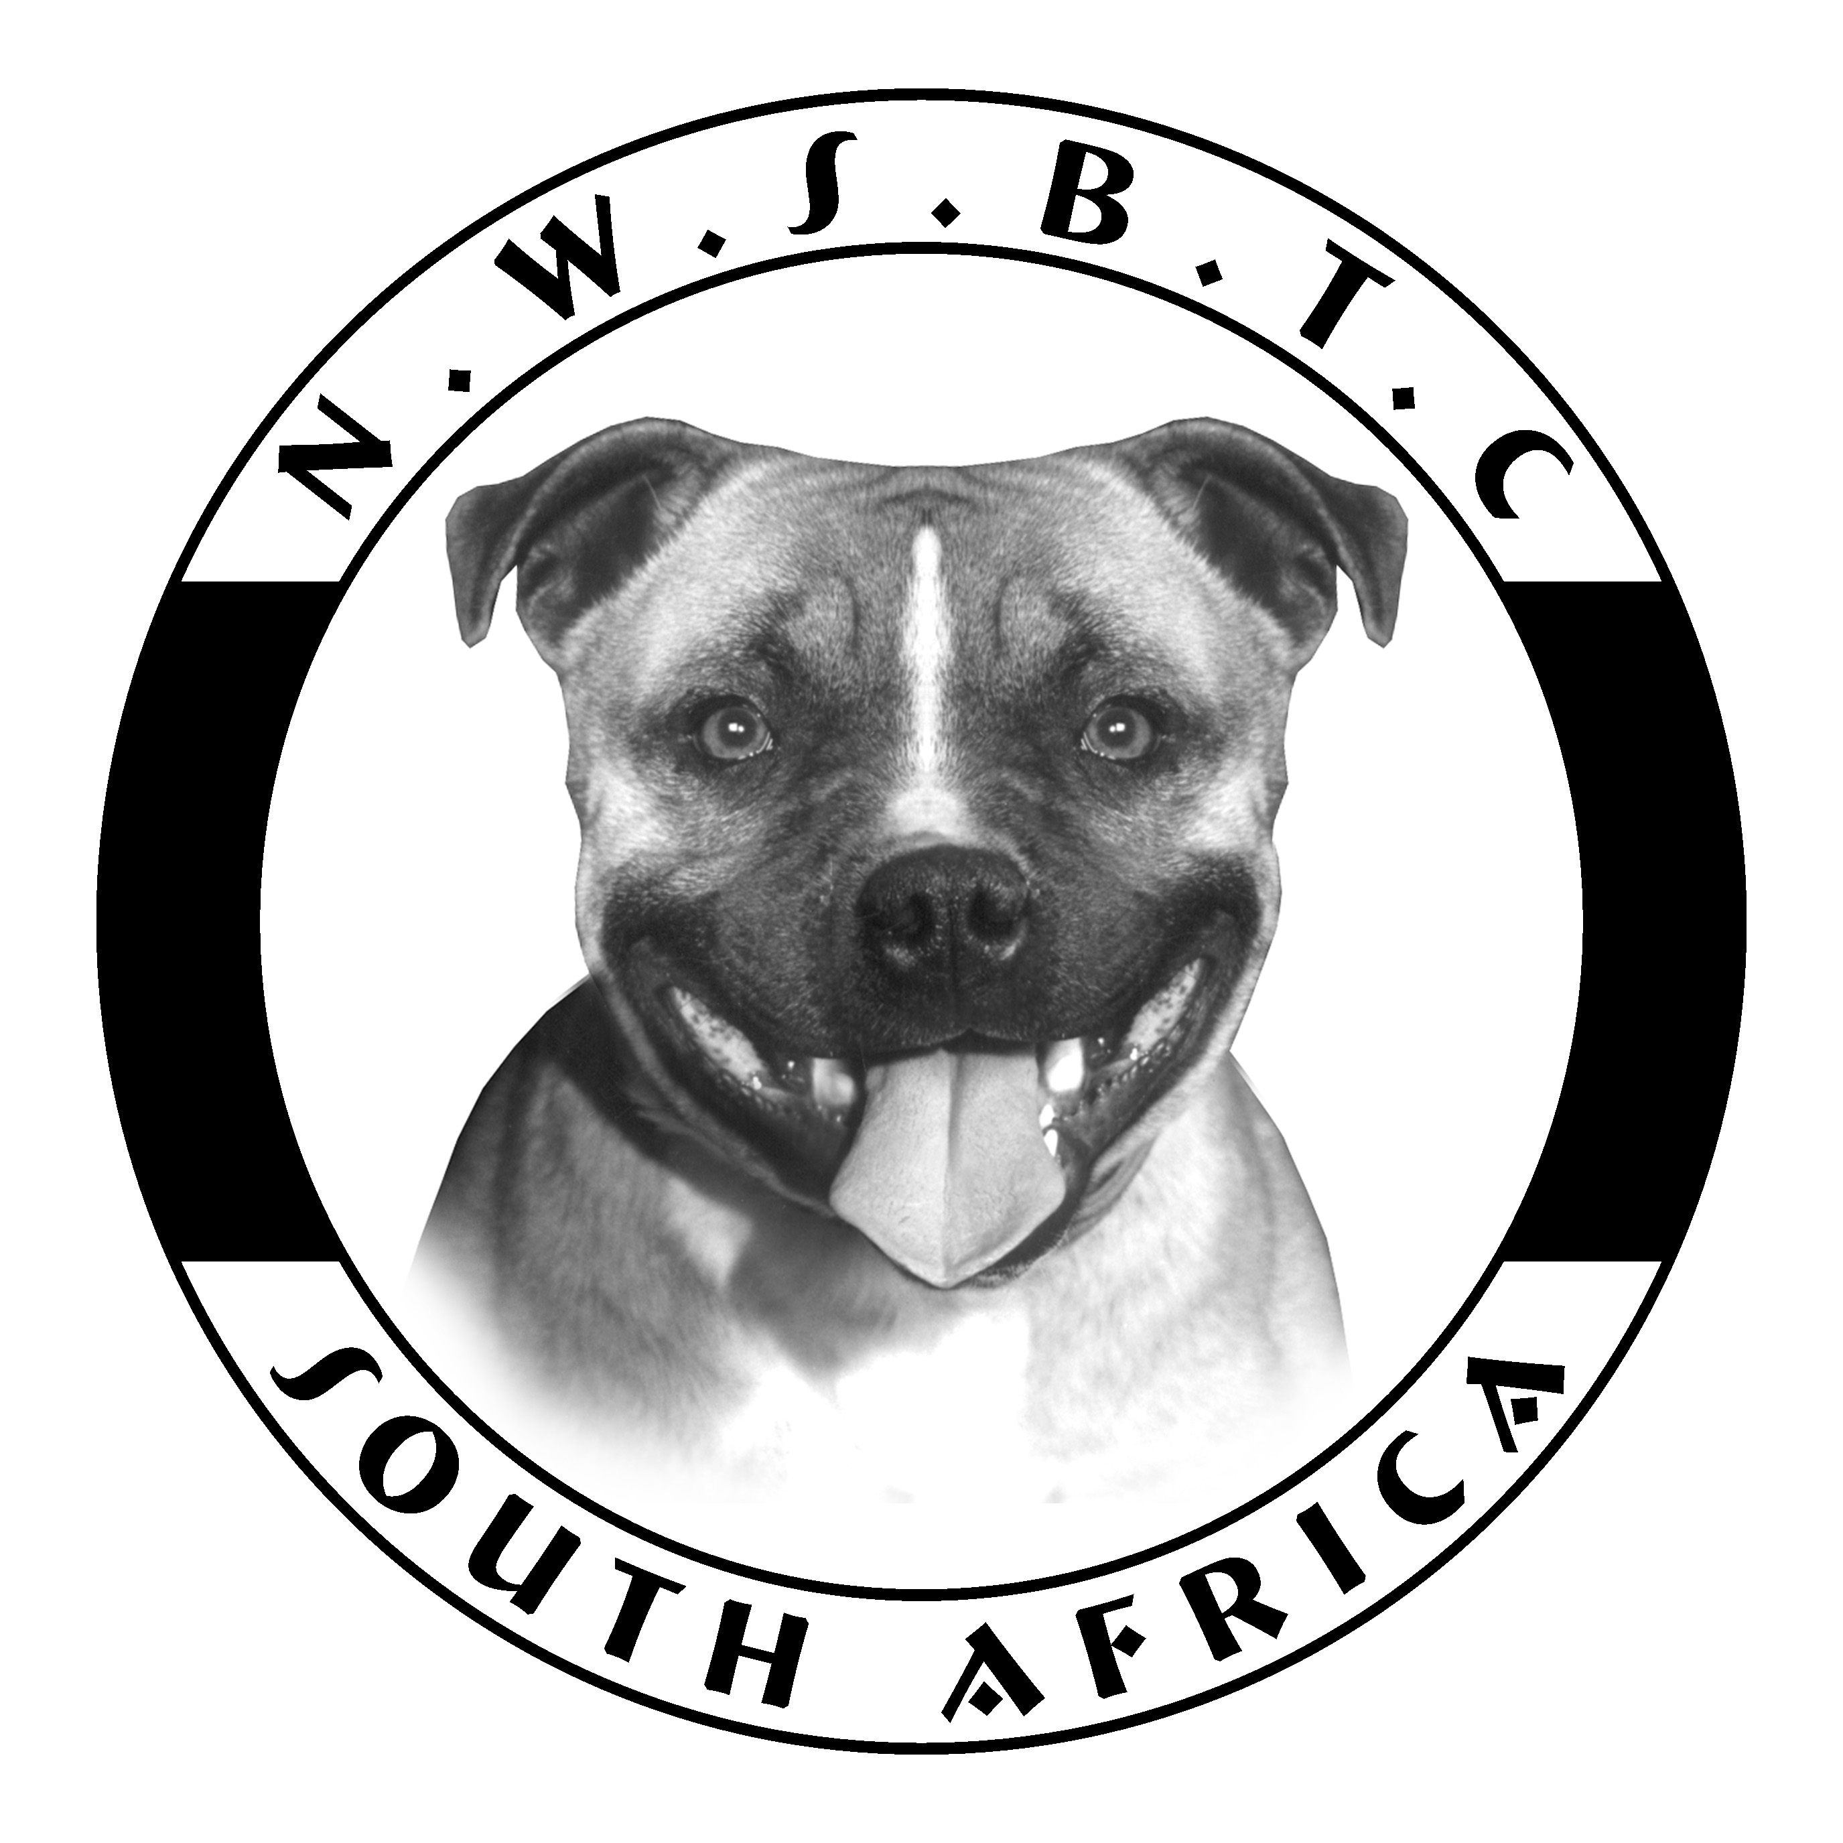

NORTH WEST STAFFORDSHIRE BULL TERRIER CLUB

ANNUAL GENERAL MEETING

NOTICE

Notice is hereby given that the Annual General Meeting of the
North West Staffordshire Bull Terrier Club
will be held at approx 12h00 before the Open Show at approx 13h00
on Saturday 21 February 2015 at the Goldfields Show Grounds

AGENDA

1. | The Notice convening the Meeting
2. | Apologies and Announcements
3. | Minutes of the previous Annual General Meeting
4. | Matters arising from the foregoing Minutes
5. | The Chairman’s Report for the Year 2014
6. | The Honorary Treasurer’s Report for the Year 2014
7. | Matters arising from Chairman’s and Treasurer’s Reports
8. | Matters submitted by the Committee
9. | Matters submitted by the Members
10. | Election of Officers and Committee Members

NOTE : Matters which do not appear in the Agenda as a specific item will not be discussed
at the Annual General Meeting. Any matter submitted by a Member should be
fully motivated and in the hands of the Honorary Secretary not less than
14 days before the Annual General Meeting.

The following Committee Members will complete their second term of Office:

Frans Steyn
Riette Steyn
Joké Vermeulen
Lauren Uffindell

Having completed their second term of Office the following Committee Members are up for re-election:

Debbie Lurie
Johann Pretorius
Natashleigh Brits
Raymond Sinclair

RIGHT OF ADMISSION RESERVED

