LIST OF DOG (SHOW) ACCESSORIES FOR SALE
DESCRIPTION | QUANTITY | SIZE (L x W x H)
Dog pen | 3 | 1200 x 1200 x 600 mm | 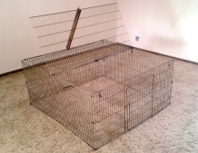
 | 1 | 1000 x 1000 x 500 mm
PVC Dog kennel | 2 | 900 x 700 x 750 mm | 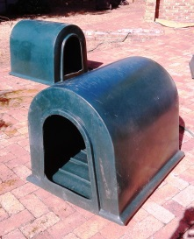
Metal travel cage (Collapsible) | 1 | 770 x 480 x 580 mm | 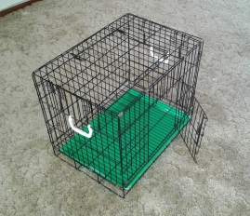
 | 2 | 600 x 420 x 500 mm
 | 1 | 470 x 310 x 400 mm
Pet Voyager carrier | 1 | 550 x 400 x 350 mm | 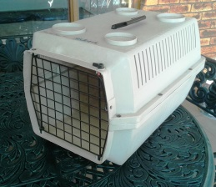
Stainless Steel feeding/water bowl | 13 | Small | 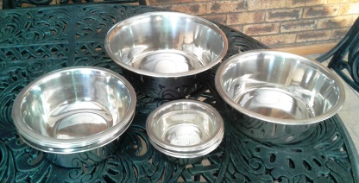
 | 5 | Medium
 | 2 | Large
 | 1 | X-large
Mars stripping knife | 1 | Fine | 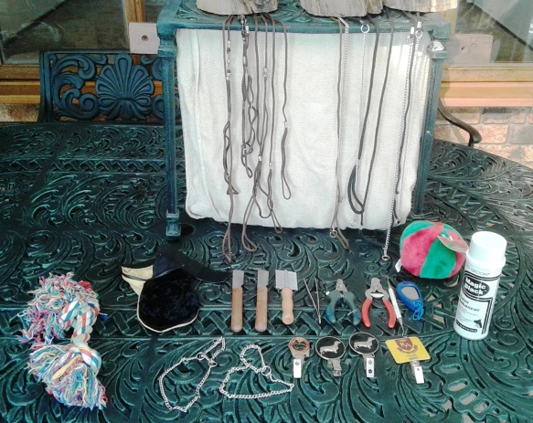
 | 1 | Medium/Course
Matt comb | 1 | Fine/course combo
Nail clipper | 2 | Small/medium breed
Clicker | 1
Choke chain | 4 | Small breed
 | 2 | Medium breed
 | 2 | Martin type small breed
Show leads | 4 | Slip type small breed
Grooming mitt | 1 | Chamois/crushed velvet combo
Show number holder | 4
Grooming table | 1 |  | 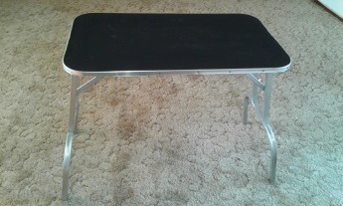
Lead stake | 1 | Can be screwed into ground | 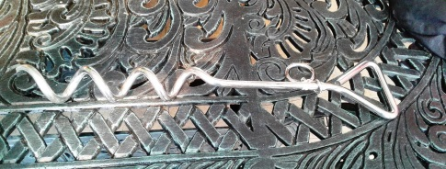
Scale | 1 | SECA baby scale. Manual, very accurate. Weighs up to 16kg.  Used to weigh miniature Dachshund for/at shows. | 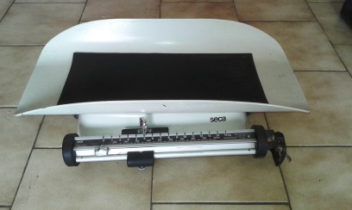
Dog blankets and bedding |  | 2 x black bags

