SHOWDOGS – RECEIVED 27/07/15

THE WORKING AND HERDING BREEDS CLUB OF THE CAPE

THIRTY-SECOND CHAMPIONSHIP SHOW
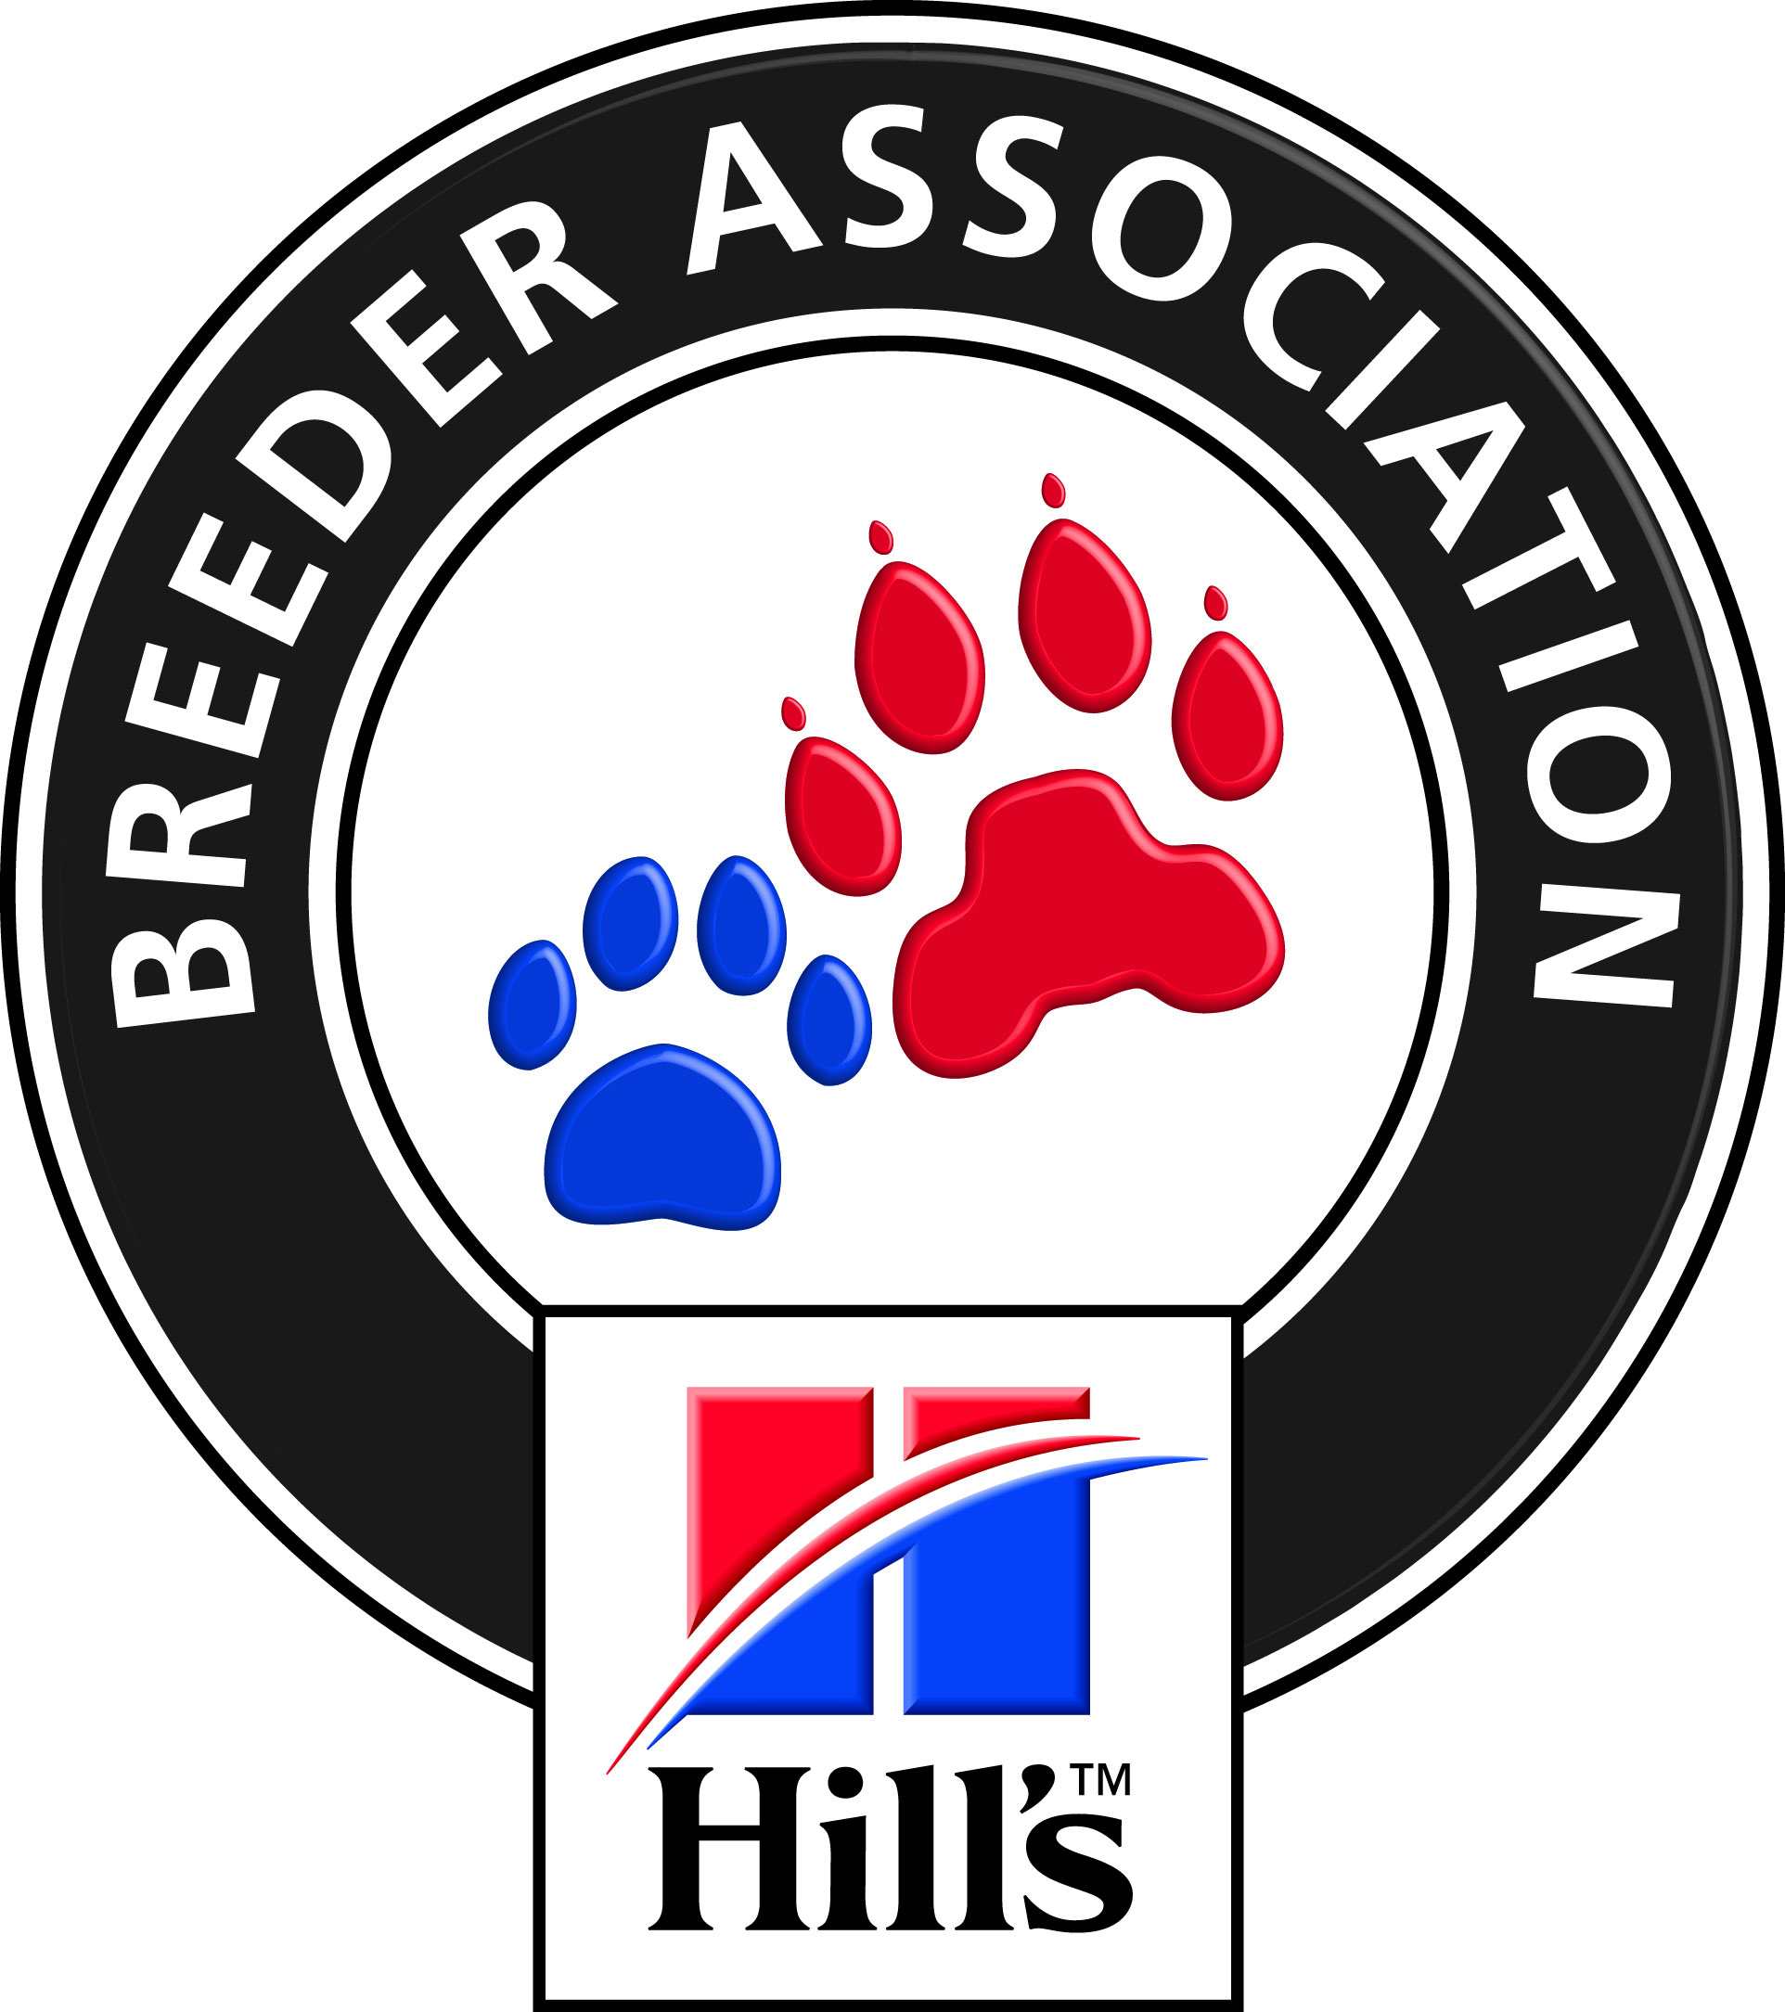

FRIDAY 23RD OCTOBER 2015

AT THE BRACKENFELL CRICKET CLUB, BRACKENFELL
JUDGES:  Entries Close | HERDING – Best PU/JU/VET/NEUT/BIS Mr S Watson (Cyprus) 10H00  WORKING (excl. BOXERS) Mr M Johnston (Australia) 10H00  BOXERS (to be judged last) Mrs L Raubenheimer  Dog Jumping Table A: All classes Mrs P v der Merwe 08H00  Agility Contact & Non Contact Mr M Taylor 08H00  Obedience Class “B” and “C” Mr J Marques 08H00  Flyball (31st Oct 2015 at Cape Handlers) Mrs A Minnaar 08H00  6 October 2015. Faxed or emailed entries must be accompanied by proof of payment.  Money deposited will not be refunded
Please note  Entry Fees Breed and Qualifying Discipline  Classes  NON-QUALIFYING  CLASSES  CATALOGUES | PLEASE ADD R 20-00 TO CASH AND CHEQUE PAYMENTS TO COVER BANK  CHARGES. Thank you.  PLEASE USE SURNAME AS REFERENCE ON PAYMENT.  Non-Members R 100-00 per dog per first class R 65-00 per additional class  Members R 95-00 per dog per first class R 60-00 per additional class  R 100-00 per Flyball team PAY AS A TEAM NOT AS INDIVIDUALS  R 45-00 per dog ( NEUTER & DISCIPLINES)  MEMBERSHIP: - R20.00 PER FAMILY AND R15.00 PER SINGLE MEMBER  R 25-00 (Group only) to be ordered and paid for with entries.
Entries & Enquiries: | Hon Secretary, Mrs Hella Fricke: Tel/Fax. 021 865 2691  P O Box 59, Koelenhof 7605 e-mail: whbc@telkomsa.net
Banking details: | ABSA , Santyger, Branch Code 632005, Savings Account No: 909 484 0695
Show Manager: | Mr. R Koning
Vet on call: | Dr le Roux, Brackenfell
KUSA Rep | Mrs D E Powell
Breed Classes: | Minor Puppy (6-9 months) Puppy (9-12 months) Junior (12 – 18 months) Graduate (18 – 24 months) S A Bred Veteran (7 years +)  Open Champions Neutered  PLEASE NOTE: There is NO BABY-PUPPY CLASS

All Exhibitors/Handlers are personally responsible for the control of their dogs at all times and shall be personally liable for
any claims which may be made in respect of injuries which may arise or be caused by their dogs
SPONSORED BY
Hill’s Pet Nutrition

