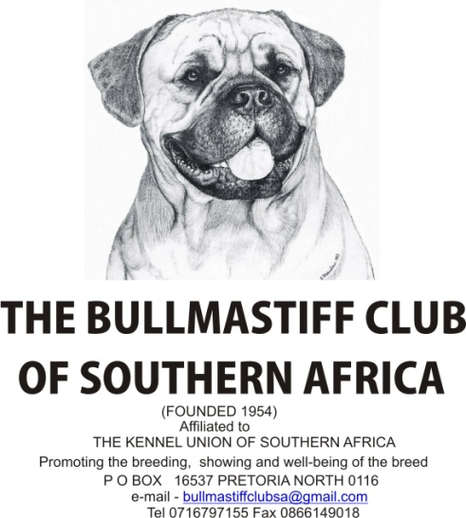
30TH CHAMPIONSHIP SHOW – SATURDAY THE 8TH OF OCTOBER 2016 at 10h00
LOWER FIELD, GOLDFIELDS SHOWGROUNDS
Enquiries: Show Secretary 011 3935194 after hours / 0716797155
Entries: Show Secretary -mailto:bullmastiffclubsa@gmail.com avsprok@mweb.co.za or Fax 0866149018
ENTRIES CLOSE ON 30.9.2016
Entry fees may be deposited directly to Nedbank Fox Street Code 190805 Account no 1908439890 and proof of deposit together with entry forms. Entries without payment will not be accepted. Please bring original documents plus proof of fax or e-mail to the show. Numbers will not be posted but must be collected at the Show from 9h00 on the morning of the Show.
JUDGE: Noreen Clark (Ireland)
BREED CLASSES: MINOR PUPPY (6-9 months) PUPPY (9-12 month) JUNIOR (12-18 months) GRADUATE (18-24 months) SA BRED, OPEN, VETERANS, CHAMPIONS, NEUTER DOG BABY PUPPY (4 – 6 months)
ENTRY FEE: MEMBERS R80.00 PER DOG PER CLASS for first 2 dogs entered, thereafter R70.00 per dog for any number of classes eligible.
NON –MEMBERS: R90.00 PER DOG PER CLASS for any number of classes eligible.
CATALOGUES: R30.00 if ordered with entry. A limited number of catalogues will be available at the Show at R40.00.
OFFICIALS: Show Manager: Mrs Carol Immelman
Show Secretary: Mrs Pat Barford
Vet on Call: Dr R Ehrlich Chairman: Mr Anton van Staden
This show will be held under KUSA show Rules & Regulations. All exhibitors/handlers are personally responsible for the control of their dogs at all times and will be personally liable for any claims may be made in respect of injuries which may or are caused by their dogs. The Club reserves the right to appoint alternate judges should any of the above be unable to officiate. No RAF or TAF dogs will be accepted. Any incomplete or illegible entries or those unaccompanied by the correct fees will be returned. Any dog entered incorrectly will automatically be entered in the Open Class. No changes will be made at the Show.
Right of admission reserved.

