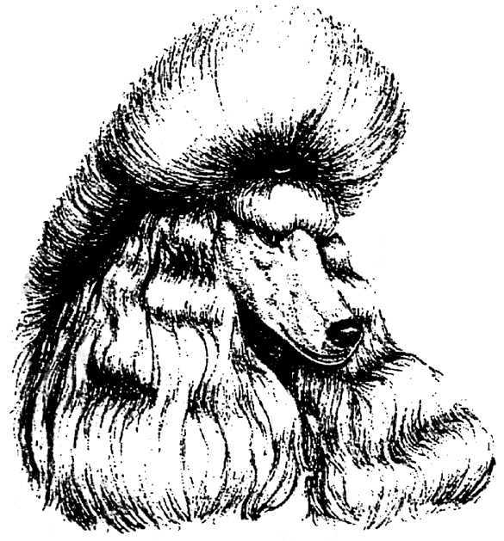

THE GOLDEN CITY POODLE CLUB

18th ANNUAL CHAMPIONSHIP SHOW
SATURDAY 16TH APRIL 2016

GOLDFIELDS KC SHOWGROUNDS BEDFORDVIEW
Lower Field

JUDGE: PERCY GREEN

JUDGING COMMENCES AT 1.00p.m. (After completion of Utility Group at WGKC)
Closing date for Entries: 24th March 2016

Entry Fees: Members R100,00 first entry, R80,00 thereafter per dog, per class
Non-members: R120, 00 per dog per class
BABY PUPPY: R60,00 per puppy per class
Breed Classes: Baby Puppy Minor Puppy, Puppy, Junior, Graduate, SA bred, Veteran, Neuter Dog, Open, Champion
Please note Baby Puppies are only eligible to win Best Baby Puppy in breed and Best Baby Puppy in Show, they are NOT eligible for the Challenge certificate
Neuter dogs are only eligible for Best Neuter on show
BEST BABY PUPPY IN SHOW, BEST PUPPY IN SHOW, BEST JUNIOR IN SHOW, BEST SA BRED IN SHOW, BEST VETERAN IN SHOW BEST NEUTER IN SHOW, BEST IN SHOW
RING STEWARD: TBA
TROPHIES: As per catalogue
This weekend has 4 CC’s on offer for Poodles with 3 overseas judges and one local judge, 2 Poodle Specialist judges and 2 Utility Specialist judges- so book your trip to Gauteng and we are going to be all POODLED OUT!!
PRIZES: As per list in Catalogue
ROSETTES: To all prize winners

CATERING: Will be available
KUSA REP:
SHOW MANAGER Jackie Browning
VET ON CALL: Dr Erhlich
ADVERTISING: R60, 00 per page complete material supplied
CATALOGUE: R50, 00 to be ordered with entries
Bitches in Season: Will be allowed
BANKING DETAILS: ABSA BANK LTD SAVINGS ACCOUNT GOLDEN CITY POODLE A/C
92-8214-5548 BRANCH CODE 632005

All entries and enquiries:
E mail: jackieb@ramsaymedia.co.za

Address: 62 Gum Road Benoni Agricultural Holdings Benoni 1512
Chairman: Francesca Cristina 083-3311683
Vice Chairman: Maurice Buisansky 011-4852185
Secretary: Jackie Browning 0829553162
This show will be held under the rules and regulations of the Kennel Union of SA

RIGHT OF ADMISSION RESERVED

