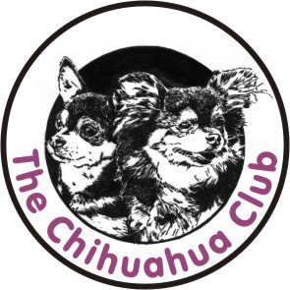 ANNUAL
OPEN
SHOW
AFFILIATED WITH KUSA
Chairman: Vice Chair: Treasurer: Secretary:
Mrs Salome Graham Mrs Annalie Oosthuizen Mrs Dani Pera Mrs Lyndal du Plessis
Cell: 082 897 9820 Cell: 083 333 4625 Cell: 083 564 2294 Cell: 083 390 3262
Date: 21 February 2016
Venue: Goldfields Kennel Club – Boeing Rd Bedfordview
Time: Entries from 9h00 Starting time: 10h00
Entry Fee: R40.00 per dog/per class

JUDGE: Mrs Y Mugatroyd
Ring Steward: Mr N Pera

Classes: Baby Puppy, Min Puppy, Puppy, Junior, Graduate, SA Bred, Open, Champions, Neuter, Veteran

Challenge: Classes: Baby Puppy, Min Puppy, Puppy, Junior, Graduate, SA Bred, Open, Champions, Neuter, Veteran, Best In Show

Judge: Child & Junior Handler (Judged at the beginning of show)
No fee if entered in class otherwise a fee of R10.00 for each entry

PLEASE NOTE: Clubs AGM meeting will be held on Saturday the 5 March 2016 at 35 Celia Nestadt Street, Benoni at 11AM

RIGHT OF ADMISSION RESERVED
This show will be held under the rules and regulations of KUSA
*All exhibitors/ handlers are personally responsible for their control of their dogs at all times and shall be personally liable for any claims which may be made in respect of injuries which may arise or be caused by their dogs. All exhibits must be on leads at all times unless otherwise instructed by a Judge

