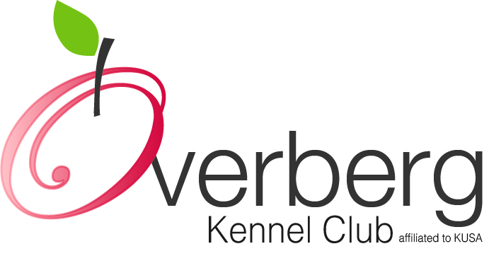
All food prizes generously sponsored by Montego Pet Nutrition
OVERBERG KENNEL CLUB NON-CHAMPIONSHIP ALL BREED SHOW

SUNDAY, 2 OCTOBER 2016 VENUE:JAGTERSHOF RUGBY CLUB, KUILSRIVER

STARTING TIMES | Judging of all groups will commence at 08h30 with Breeds in alphabetical order
ENTRIES | Entries can be emailed to obwckc@gmail.com until 24h00, Thursday, 29 September 2016. Entries will be taken until 08h00 on the day.  Entry Fees - Breed: R 40 for members on / before 29 September and R 45 on the day; Non-members: R 45 on / before 29 September and R 50 on the day.  Child and Junior Handlers: R 20, with no charge if entered in Breed.
BANKING DETAILS | Bank and Branch: Capitec, Hermanus  Savings Account Name: Overberg Kennel Club  Account Number: 1428418316; Branch and EFT Code: 470010
ENQUIRIES | Jetty Botes-Erasmus: (028) 273-8187 or 082786 5323
CLASSES / GRADES | Baby Puppy (4-6 months), Minor Puppy (6-9 months), Puppy (9-12 months), Junior (12-18 months), Graduate (18-24 months), SA Bred, Veterans, Open, Champions, Neuter Dog, Child (8-11 years) and Junior (11-18 years) Handlers.  Please Note: Baby Puppy, Veterans, Neutered Dogs and Champions MAYNOTCOMPETEfor Best of Breed, but each Baby Puppy, Veteran, Neutered Dogand Champion group winner will go forward to Best Baby Puppy in Show, Best Veteran in Show, Best Neutered Dog in Show and Best Champion in Show. All RBoB winners will go forward to the Best Mini Grand in Group and the group winner will go forward to Best Mini Grand in Show.
WORKING DISCIPLINES | No working disciplines on offer (Championship show hosted by WP Boxer Club)
BIS CHALLENGES | Best in Show(In judging order): Baby Puppy, Junior, Veteran, Neutered Dog, Champion, Mini Grand,Puppyand Best in Show.
SPECIAL NOTICE | Miniature Dachshunds will not be weighed
BREED JUDGES
GUNDOG | Mrs E A Raubenheimer
HERDING | Ms MB Heystek
HOUND | Mr D J Kritzinger
TERRIER | Mr N J Nagel
TOY | Ms EA Mason
UTILITY | Mrs J Wang
WORKING | Mrs AAEsterhuizen
ALL BEST IN SHOWS | Mrs HS Impey
CHILD & JUNIOR HANDLERS
JUDGE | Mrs HS Impey
VET ON CALL | Tygerberg Animal Hospital: (021) 9191191

THIS SHOW/EVENT WILL BE HELD UNDER THE RULES AND REGULATIONS OF THE KENNEL UNION OF SOUTHERN AFRICA (KUSA)

All exhibitors/handlers are personally responsible for the control of their dogs at all times and shall be personally liable for any claims which may be made in respect of injuries which may arise or be caused by their dogs. All exhibits must be on leads at all times unless otherwise instructed by a Judge. Bitches in season will be permitted to compete in Breed classes. The Committee reserves the right to appoint alternative judges at its discretion.

- Please be vigilant and watch out for your belongings.
- No cars will be allowed on the fields at any time.
- Catering will be available

RIGHT OF ADMISSION RESERVED

