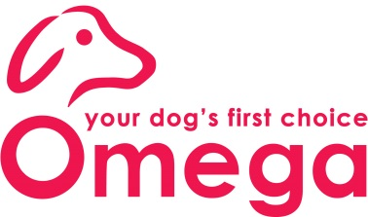
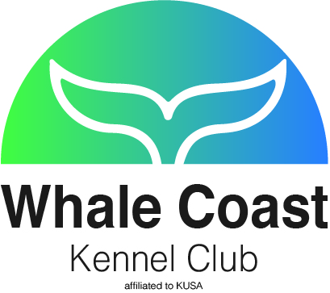
WHALE COAST KENNEL CLUB
NON-CHAMPIONSHIP ALL BREED SHOW
SUNDAY, 2 OCTOBER 2016

VENUE:Jagtershof Rugby Club, Kuilsriver

STARTING TIMES | Breed:± 12h00, (After breed judging of Overberg Kennel Club)
ENTRIES | Entries can be emailed to obwckc@gmail.com until 24h00, Thursday, 29 September 2016. Entries will be taken until 08h00 on the day.  Entry Fees - Breed: R 40 for members on / before 29 September and R 45 on the day; Non-members: R 45 on / before 29 September and R 50 on the day.  Child and Junior Handlers: R 20, with no charge if entered in Breed.
BANKING DETAILS | Bank and Branch: Capitec, Hermanus  Savings Account Name: Whale Coast Kennel Club  Account Number and Code: 1428417654; Branch and EFT Code: 470010
ENQUIRIES | Madelein Rautenbach: (028) 316 3382 / 082 619 3128
CLASSES / GRADES | Baby Puppy (4-6 months), Minor Puppy (6-9 months), Puppy (9-12 months), Junior (12-18 months), Graduate (18-24 months), SA Bred, Veterans, Open, Champions, Neuter Dog, Child (8-11 years) and Junior (12-18 years) Handlers.  Please Note: Baby Puppy, Veterans, Neutered Dogs and Champions MAYNOTCOMPETEfor Best of Breed, but each Baby Puppy, Veteran, Neutered Dogand Champion group winner will go forward to Best Baby Puppy in Show, Best Veteran in Show, Best Neuter in Show and Best Champion in Show. All RBoB winners will go forward to the Best Mini Grand in Group and the group winner will go forward to Best Mini Grand in Show.
WORKING DISCIPLINES | No working disciplines (Championship show hosted by WP Boxer Club)
BIS CHALLENGES | Best in Show (In judging order): Baby Puppy, Junior, Veteran, Neutered Dog, Champion, Mini Grand, Puppy and Best in Show.
SPECIAL NOTICE | Miniature Dachshunds will not be weighed
BREED JUDGES
GUNDOG | Mrs CUF Larkin | HERDING | Ms EA Mason
HOUND | Mrs J Wang | TERRIER | Mrs L E Louw
TOY | Mrs HS Impey | UTILITY | Mr J Van Rijswijk
WORKING | Mr J N Meyer | CHILD & JUNIOR HANDLER | Mr J Nagel
BEST BABY PUPPY IN SHOW | Mrs E A Raubenheimer | BEST VETERAN IN SHOW | Mrs E A Raubenheimer
BEST JUNIOR IN SHOW |  | BEST NEUTER IN SHOW
BEST CHAMPION IN SHOW |  | BEST PUPPY IN SHOW | Mr J Van Rijswijk
BEST MINI GRAND IN SHOW | Mrs J Wang | SHOW BEST IN SHOW | Mr G Bidder

THIS SHOW/EVENT WILL BE HELD UNDER THE RULES AND REGULATIONS OF THE KENNEL UNION OF SOUTHERN AFRICA (KUSA)

All exhibitors/handlers are personally responsible for the control of their dogs at all times and shall be personally liable for any claims which may be made in respect of injuries which may arise or be caused by their dogs. All exhibits must be on leads at all times unless otherwise instructed by a Judge. Bitches in season will be permitted to compete in Breed classes only. Due consideration must be given to competitors in Obedience, Dog Jumping, Agility and other Disciplines. The Committee reserves the right to appoint alternative judges at its discretion.

- Please be vigilant and watch out for your belongings.
- No cars will be allowed on the fields at any time.
- Catering will be available.

RIGHT OF ADMISSION RESERVED

This show has beengenerously sponsored by Omega Pet Foods

