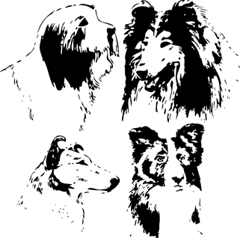
THE COLLIE CLUB OF SOUTH AFRICA
CHAMPIONSHIP SHOW
SUNDAY 9TH JULY 2017
After Herding Group at EDKC – not before 12h30
Goldfields Grounds, Johannesburg
Judge: Peerapong Pisitwuttinen (Thailand)
Bearded, Border & Rough Collies
Classes: Minor Puppy (6-9 mths), Puppy (9-12 mths), Junior (12-18 mths),
Graduate (18-24mths), SA Bred, Veteran (7 yrs & over), Champions,
Neutered Dog, Baby Puppy (4-6 mths)
ORDER OF JUDGING: CLASSES AS ABOVE
BISs: BEST BABY PUPPY, BEST PUPPY,BEST JUNIOR,
BEST VETERAN, BEST NEUTER, BIS

Challenges:(R10 per class) Gait, Brace, Dam/Sire & Progeny, Best Expression
Entry Fees: R100 for first dog, R90 for subsequent dogs
Members R90 for first dog, R80 for subsequent dogs
Baby Puppy & Neutered Dogs R50 (not eligible for CCs)
NEDBANK, ACC. 1921 012 455

Entries to: collieclubsa@gmail.com Fax 086 775 8949
Enquiries: Glenda 083 312 1038 or 011 802 4432
ENTRIES CLOSE 26 June. NO LATE ENTRIES PLEASE

EXHIBITORS ARE INVITED TO LUNCH AFTER THE SHOW

Show Manager: M Wright. Show Secretary: G de Taranto
Vet: Dr R Ehrlich.

NB: This show will be held under the rules and regulations of the Kennel Union of Southern Africa

All exhibitors are personally responsible for the control of their dogs at all times and shall be personally liable for any claims which may be may arise or be caused by their dogs

Bitches in season allowed. Please show consideration for other exhibitors

