NON CHAMPIONSHIP SHOW
3 JUDGES
Joy Mc Farlane - Breeds A to E
Tania Edwards - Breeds F to O
Elrena Stadler – Breeds P to Z
JUDGING WILL BE IN BREED ALPHABEICAL ORDER
Saturday 22 April 2017 at 2pm
CAPE HANDLERS DOG CLUB
Catering and Bar available at venue
THEO MARAIS PARK
KOEBERG ROAD
MILNERTON
BREED
R50 per dog per class – Entries on the day from 12 noon
‘BEST IN SHOW’
WILL BE JUDGED BY
ALL 3 JUDGES
Bank Details should you wish to pre-enter:
Nedbank Stellenbosch
Branch Code: 107110
Account Number: 1033576050
Breed Classes
Baby Puppy * 4 to 6 months
Show Manager
Barry Canning
Show Secretary
Lori Kasselman
Vet on Call
Panorama Vet Clinic
Minor Puppy 6 to 9 months
Puppy 9 to 12 months
Junior 12 to 18 months
Graduate 18 to 24 months
SA Bred Must be bred in SA
Neutered Dog*
Veteran 7years and older
Open Unrestricted
Champion Champions only

*Baby puppy – neutered dogs not eligible for Best of Breed
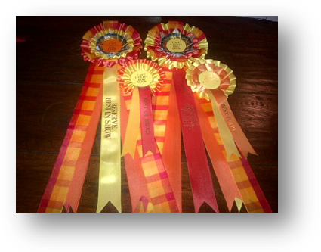Compete for Best Baby Puppy in Show and Best Neutered Dog in Show

BEST IN SHOW ORDER OF JUDGING
- Best Baby Puppy
- Best Neutered Dog
- Best Junior
- Best Veteran
- Best Puppy
- Best in Show
This show will be held under the Rules and Regulations of the Kennel Union of Southern Africa.
All Exhibitors/Handlers are personally responsible for the control of their dogs at all times and shall be personally liable for any claims which may be made in respect of injuries which may arise or be caused by their dogs.
Right of admission reserved

THIS SHOW IS BEING HELD IN CONJUCTION WITH OTHER UTILITY BREED SHOWS
SATURDAY 10:00 AM | SATURDAY 14:00
3 SEPARATE RINGS – 3 SEPARATE JUDGES | CAPE UTILITY DOG CLUB  BREEDS DIVIDED ACROSS 3 JUDGES  ALL ‘BEST IN SHOW’ TITLES  WILL BE JUDGED BY ALL 3 JUDGES
CAPE BULLDOG CLUB
FRENCH BULLDOG CLUB OF THE WESTERN CAPE
MOTHER CITY POODLE CLUB

NOTE:
- Please keep the sports ground and club house clean and tidy.
- All exhibitors/handlers are personal responsible for the control of their dogs at all times and shall be personally liable for any claims which may be made in respect of injuries and/or damage which may arise or be caused by their dogs.
- Dogs must be kept on a lead/leash or firmly secured at all times.

KINDLY ADHERE TO THE CAPE HANDLERS DOG CLUB RULES

NO PRIVATE LIQUOR TO BE BROUGHT ONTO THE PREMISES

The Theo Marais Sports Ground has a liquor licence that is extended to all of the Sports Clubs on the precinct. The CHDC is obliged to respect the rules of the management of the Sports Grounds.

DOGS ARE NOT ALLOWED ON ANY FIELD OTHER THAN CAPE HANDLERS

Complaints have been received from the baseball and rugby club pertaining to people not cleaning up after their dogs, so please ensure your dogs remain on the CHDC grounds.

PARKING ONLY PERMITTED BEHIND THE LOG BARRIERS

Kindly ensure that ALL vehicles are parked behind the log barriers around the field. Parking on the grass surrounding the ring will not be allowed.

DOGS ARE NOT ALLOWED IN THE CLUB HOUSE
The grassed area within the fence of the Clubhouse is a children’s’ play area. Please respect the rules and do not take your dogs into this area or into the clubhouse.

