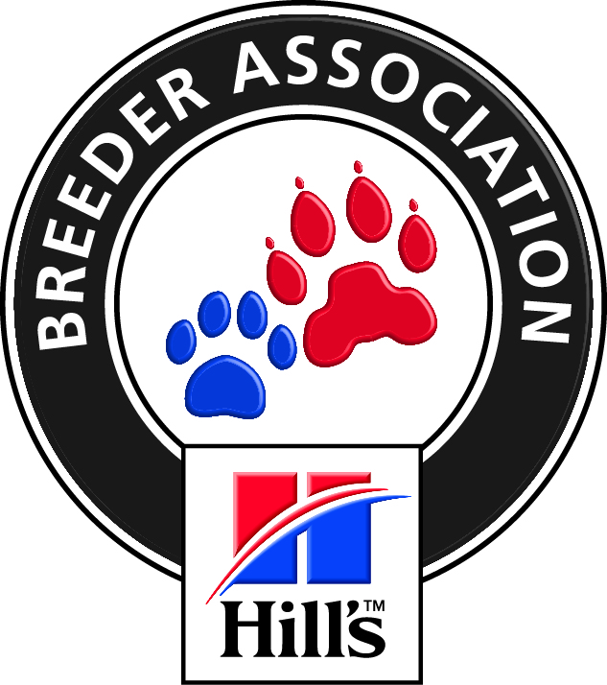

**THE MOTHER CITY POODLE CLUB**

Affiliated to the Kennel Union of Southern Africa

Open Breed Show

**Judge: TANIA EDWARDS**

MINIATURE, STANDARD, TOY POODLES

**Saturday 22ndApril 2017 at Cape Handlers Dog Club, Milnerton at 10.00 am**

**Entry fees on the day**

Non-Members: R55.00 per dog per class

Members: R45 per dog per class for first 2 dogs, R40 for 3rd dog per class,, thereafter R30 per dog per class

Enquiries: Fay 0711384385 Email: fayfifi8@gmail.com

Membership R120.00 for 2017 (March to February)

|  |  |
| --- | --- |
| *Do not compete for BOB or BIS  *Do Not compete for BOB or BIS  *Do Not compete for BOB or BIS  BBPIS,BCHIS,BNIS | *Baby puppy 4 -6 months  Minor Puppy 6-9 months  Puppy 9-12 months  Junior 12-18 months  Graduate 18-24 months  SA bred  Veteran 7 years onwards  Open  *Champions  *Neuter Male dogs |
| **Challenges below Judged after BIS. R5.00 Entry. Free Entry for those entered in classes Standard Miniature and Toys in ring together in this order for each class.**  Best Black, Best White, Best Red, Best Brown, Best Presentation of coat, Best Rescue Best Pet, Child and Junior handling. | |

**All Exhibitors/Handlers are personally responsible for the control of their dogs at all times and shall be personally liable for any claims which may be made in respect of injuries which may arise or be causedby their dogs. All Exhibits must be on leads at all times unless otherwise instructed by a Judge. Please do not put gazebo/umbrella stakes into grounds near any irrigation system. Do not drive on field.**

**NO BITCHES IN SEASON ALLOWED ON GROUNDS RIGHT OF ADMISSION RESERVED**