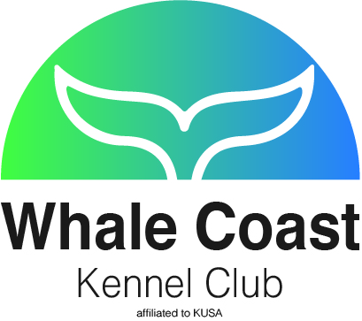VENUE: Jagtershof Rugby Club, Kuilsriver
WHALE COAST KENNEL CLUB
ALL BREED QUALIFYING SHOW
SUNDAY, 1 October2017

STARTING TIMES | Handlers: 09h30 Breed: 10h00
ENTRIES CLOSE | 15 September 2017. No late entries will be accepted.
ENTRY FEES | Members: R 60 per dog per class for the first three dogs. Thereafter R 40 per dog per class. Non-members: R 70 per dog per class for the first three dogs. Thereafter R 50 per dog per class. Child and Junior Handlers: R 30 if exhibit is not entered in Breed.  EFT or cash deposits only. No cheques will be accepted. Please add R 20 for all cash deposits to cover bank charges. Proof of payment to be sent with entries. Incomplete or illegible entries or those unaccompanied by the correct fees or proof of payment will be returned to the exhibitor.
CATALOGUES | R 70 with entry - Group
ENQUIRIES CLUB SECTRETARY | Madelein Rautenbach: (028) 316 3382 / 082 619 3128
CHAIRLADY | Jetty Botes |  | SHOW MANAGER |  |  | Kobus J v Rensburg
VET ON CALL | Tygerberg Animal Hospital |  | Tel: 021 919 1191
EMAIL ENTRIES | whalecoastkc@gmail.com |  | FAX ENTRIES |  |  | 086 244 4876
BANKING DETAILS | Bank and Branch: Capitec, Hermanus.  Savings Account Name: Whale Coast Kennel Club.  Account Number and Code: 1428417654; Branch and EFT Code: 470010
CLASSES / GRADES | Baby Puppy (4-6 months)*, Minor Puppy (6-9 months), Puppy (9-12 months), Junior (12-18 months), Graduate (18-24 months), SA Bred, Veterans, Open, Champions, Neuter Dog*, Child (8-11 years) and Junior (12-18 years) Handlers.  * Not eligible for Best of Breed  Please Note: No KUSA awards will be issued at this qualifying show.
WORKING DISCIPLINES | No working disciplines at this show
BIS CHALLENGES | Best in Show challenges (in judging order): Baby Puppy, Junior, Veteran, Neutered Dog, Puppy and Best in Show.
SPECIAL NOTICE | Miniature Dachshunds will not be weighed
JUDGES
GUNDOGS | Mrs J M Musto | HERDING |  |  | Ms H Basson
HOUNDS | Mrs J D Whittingham | TERRIERS |  |  | Mrs L Louw
TOYS | Mrs Y E Bouls | UTILITY |  |  | Mrs D E Powell
WORKING | Mrs H S Impey | HANDLERS |  |  | Mrs J M Musto
ALL BEST IN SHOWS |  |  |  | Mrs H S Impey

THIS SHOW/EVENT WILL BE HELD UNDER THE RULES AND REGULATIONS OF THE KENNEL UNION OF SOUTHERN AFRICA (KUSA)

All exhibitors/handlers are personally responsible for the control of their dogs at all times and shall be personally liable for any claims which may be made in respect of injuries which may arise or be caused by their dogs. All exhibits must be on leads at all times unless otherwise instructed by a Judge. Bitches in season will be permitted to compete in Breed classes only. The Committee reserves the right to appoint alternative judges at its discretion.

- Please be vigilant and watch out for your belongings.
- No cars will be allowed on the fields at any time.
- Catering will be available.
RIGHT OF ADMISSION RESERVED
This show has been generously sponsored by
Montego Pet Nutrition

