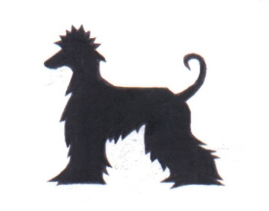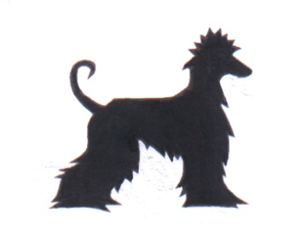ern
Afghan Hound Association
of Southern Africa

37TH ANNUAL CHAMPIONSHIP SHOW

SPONSORED BY MONTEGO

SUNDAY 15th APRIL 2018 10.00am

VENUE : GOLDFIELDS SHOWGROUNDS, BEDFORDVIEW, LOWER FIELD
Enquiries: Clair van den Bergh Tel: 072 350 8583 E-mail: clair75@gmail.com

Entries close: 31st March 2018 (numbers to be collected at show from 9.00am)

Entries to: clair75@gmail.com

Banking details: Nedbank, Isando, Branch No. 196142, Account No. 1587008009,
Account name: Afghan Hound Association of South Africa

Please Note entries CANNOT be accepted without the correct fees. Entries marked RAF/TAF will not be accepted

COMMITTEE: Clair van den Bergh (Chairlady), Elsie De Bruin (Vice Chairman), Sue Mitchell (Secretary/Treasurer),
Dorothy Deeb, Stephanie Geral, Neville Schwarzer, Hiroshan Moodley, Sharon Crawford.

Judge: Stefan Boieck (Agha Djari’s – Germany)
(The committee reserves the right to appoint another judge should the above fail to keep her appointment.)

Show Manager: Clair van den Bergh Ring Steward: TBA Vet: TBA

Classification of Breed: Afghan Hound

Entry fees: None AHASA Members : R110 an Entry & R15 Challenges.
AHASA Members: R100 1st Entry, thereafter R90 per entry
R70-00 for Neutered Dog & Baby Puppy classes
R10 – Challenge classes

Classes: *Baby Puppy (4-6 months), Minor Puppy (6-9 months), Puppy (9-12 months), Junior (12-18 months),
Graduate (18-24 months), SA Bred, *Neutered Dog, Veterans, Open, Champion. (*these classes don’t compete for the CC)

Challenge Classes: Best Pet Afghan (Introducing new Challenge class), Head, Tail, Coat, Imported, Gait, Puppy Gait, Breeders, Progeny.

Prizes: Rosettes, Montego Dog food & various
specials will be awarded.

Please note order of judging will be Baby puppy, Minor puppy, Puppy, Junior, Graduate, S A Bred, Neutered Dog, Veteran, Open, (same for bitches excluding Neutered). Then CC will be judged (excluding Baby Puppy and Neutered Dog). Then normal judging sequence will follow. Best In Show awards will be judged according to KUSA regulation 24.4 followed by Best Junior, Graduate, Veteran, SABIS.

!! Our judge will be on the look out for our ‘BEST HANDLER’ of the day !!

This show will be conducted under the rules & regulations of the Kennel Union of Southern Africa. Exhibitors/Handlers are personally responsible for the control of their dogs at all times & shall be personally liable for any claims which may be made in respect of injuries which may arise or be caused by their dogs. PLEASE NOTE: Bitches in season will be allowed but exhibitors are requested to exercise consideration towards others.

Please join us after the Show for luncheon

RIGHT OF ADMISSION RESERVED

