THE WORKING AND HERDING BREEDS CLUB OF THE CAPE
THIRTY-FIFTH CHAMPIONSHIP SHOW
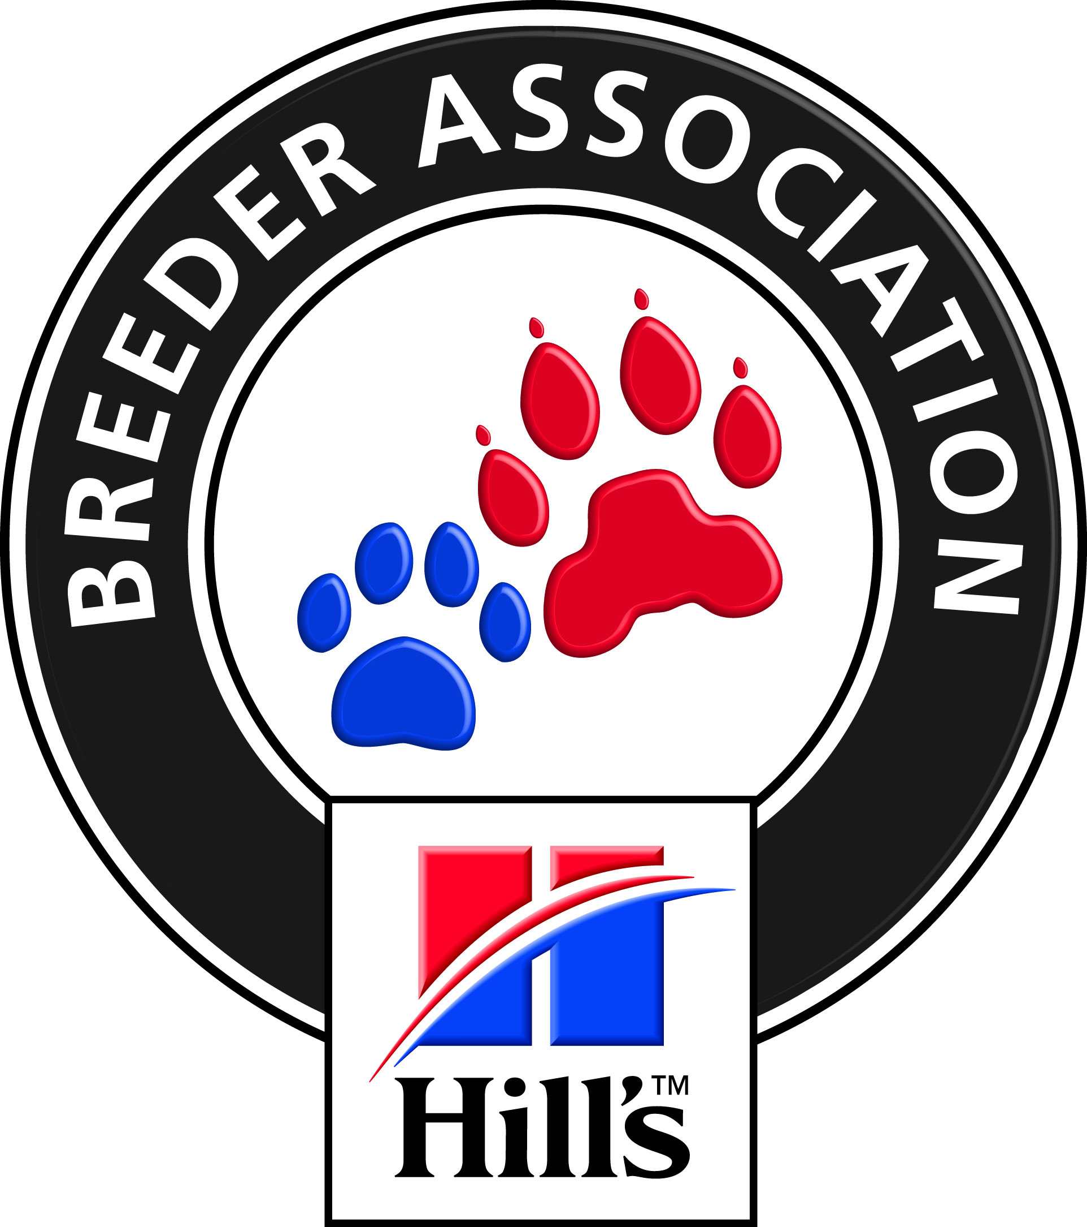

FRIDAY 26 OCTOBER 2018 2012018

AT THE BRACKENFELL CRICKET CLUB, BRACKENFELL
PLEASE NOTE: Only Members of the Kennel Union shall be entitled to enter dogs in their registered ownership in any Championship Dog Show licenced by the Kennel Union.

JUDGES BREED:  Entries Close | HERDING GROUP Mrs L Harwood (Aust) 10H00  WORKING GROUP, Best PU/JU/VET/NEUT - BIS Mrs J Manton (Ireland) 10H00  9th October 2018. Faxed or e-mailed entries must be accompanied by proof of payment.  Money deposited will not be refunded
Please note  Entry Fees:  Breed  Catalogues: | PLEASE ADD R 20-00 TO CASH AND CHEQUE PAYMENTS  TO COVER BANK CHARGES. Thank you.  PLEASE USE SURNAME AS REFERENCE ON PAYMENT.  Non-Members R 120-00 per dog per class  Members R 110-00 per dog per class  MEMBERSHIP: - R20.00 PER FAMILY AND R15.00 PER SINGLE MEMBER  R 25-00 (Group only) to be ordered and paid for with entries.
Entries & Enquiries: | Hon Secretary, Mrs Hella Fricke: Tel: 076 170 7218 Fax: 086 218 9877  P O Box 59, Koelenhof 7605 e-mail: whbc@telkomsa.net
Banking details: | ABSA , Santyger, Branch Code 632005, Savings Account No: 909 484 0695
Show Manager: | Mr. R Koning
Vet on call: | Dr le Roux, Brackenfell
KUSA Rep | Mrs D E Powell
Breed Classes: | Minor Puppy (6-9 months) Puppy (9-12 months) Junior (12 – 18 months) Graduate (18 – 24 months) S A Bred Veteran (7 years +)  Open Champions Neutered  PLEASE NOTE: There is NO BABY-PUPPY CLASS
Judging order GROUP/BIS | BEST NEUTER / BEST PUPPY / BEST JUNIOR / BEST VET / GROUP - BEST IN SHOW
BITCHES IN SEASON are allowed in the BREED Ring
All Exhibitors/Handlers are personally responsible for the control of their dogs at all times and shall be personally liable for
any claims which may be made in respect of injuries which may arise or be caused by their dogs
SPONSORED BY
Hill’s Pet Nutrition

