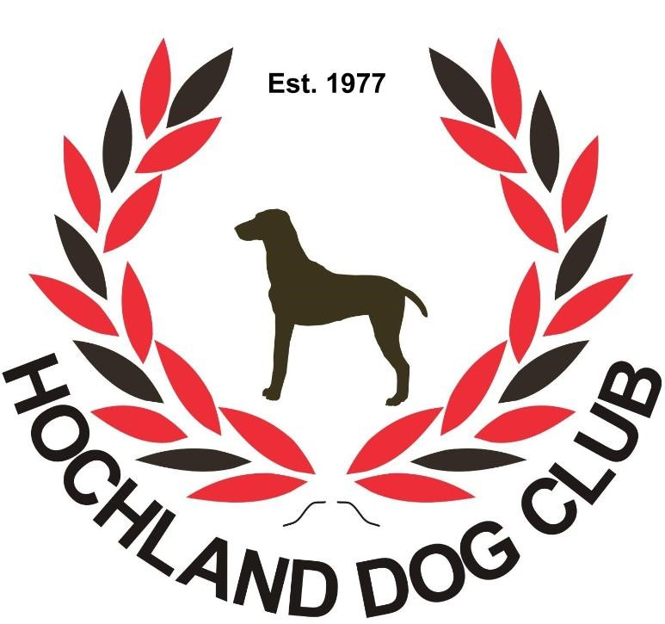



**HOCHLAND DOG CLUB  
ALL BREED CHAMPIONSHIP SHOW II**

**SUNDAY, 28 July 2019**

**Venue: GSD Club Grounds, Frankie Federicks Street, Olympia, Windhoek**

|  |  |  |  |
| --- | --- | --- | --- |
| **STARTING TIMES** | **Handlers**: 09:00**Breed:**After the completion of the handler classes | | |
| **ENTRIES CLOSE** | 27thJune2019.**No late entries will be accepted.** | | |
| **ENTRY FEES**  **Breed Classes** | **HDC Members:** N$ 70.00  **Non HDC Members:** N$ 110.00 | | |
| **IMPORTANT NOTICE** | EFT or cash deposits only. **No cheques** will be accepted. **Please add N$ 30.00 for all cash deposits to cover bank charges.** Proof of payment to be sent with entries. Incomplete or illegible entries or those unaccompanied by the correct fees or proof of payment will be returned to the exhibitor. | | |
| **CATALOGUES** | N$ 50.00 | | |
| **ENQUIRIES CLUB SECTRETARY** | **Ilka van Niekerk:**hochlanddogclub@outlook.com | | |
| **CHAIRMAN** | Marc van Niekerk | **SHOW MANAGER** | Conny Maritz |
| **EMAIL ENTRIES** | hochlanddogclub@outlook.com | **SHOW SECRETARY** | Ilka van Niekerk |
| **BANKING DETAILS** | **Bank and Branch:**First National Bank, Windhoek  **Name:**Hochland Dob Club.  **Account Number:**55500120395; **Branch Code**: 280172 | | |
| **BREED CLASSES / GRADES** | Baby Puppy (4-6 months)**\***, Minor Puppy (6-9 months), Puppy (9-12 months), Junior (12-18 months), Graduate (18-24 months), SA Bred, Namibian bred, Import, Veterans, Open, Neuter Dog**\***, Child handling (8-11 years), Junior handling (12-18 years) Open handling (18+).  **\* Not eligible for the CC or Best of Breed** | | |
| **GROUP JUDGING**  **(In judging order)** | Best Baby Puppy In Group, Best Puppy In Group, Best Junior In Group, Best Veteran In Group, Best Namibian Bred In Group, Best In Group | | |
| **BIS CHALLENGES**  **(In judging order)** | Breeders Challenge, Baby Puppy, Junior, Namibian bred,Veteran, Neutered Dog,Puppy and Best in Show.  **After Best in Show for paid up HDC members only**: Best South African bred, Best Import, Non-Kusa Handling Classes | | |
| **JUDGE**  *All GROUPS*  *ALL BIS CHALLENGES* | **Mrs. Rose-Marie Cabion (Western Cape, South Africa**) | | |

**THIS SHOW/EVENT WILL BE HELD UNDER THE RULES AND REGULATIONS OF THE KENNEL UNION OF SOUTHERN AFRICA (KUSA)**

All exhibitors/handlers are personally responsible for the control of their dogs at all times and shall be personally liable for any claims which may be made in respect of injuries which may arise or be caused by their dogs. All exhibits must be on leads at all times unless otherwise instructed by a Judge. Bitches in season will be permitted to compete, however it is advised that the owner informs the committee beforehand. The Committee reserves the right to appoint alternative judges at its discretion.

* Please be vigilant and watch out for your belongings.
* No cars will be allowed on the fields at any time.
* Catering will be available, please support the club.

Club officials: Marc van Niekerk (Chairman),   
 Ilka van Niekerk (Secretary/treasurer), Nathan Davies (Committee member),   
 Conny Maritz (Committee member)

“Only Members of the Kennel Union shall be entitled to enter dogs in their registered ownership in any Championship Dog Show licensed by the Kennel Union.”

**RIGHT OF ADMISSION RESERVED**