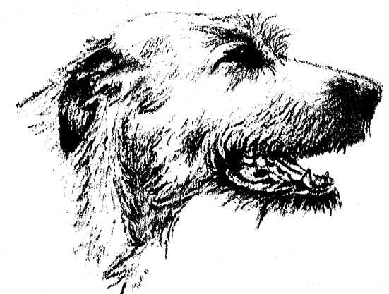
IRISH WOLFHOUND CLUB OF GAUTENG
31st Annual ChampionshipShow
Sunday 14th April 2019

Venue: | GOLDFIELDS KENNEL CLUB, LOWER GROUNDS, BOEING ROAD WEST, BEDFORDVIEW, JOHANNESBURG, GAUTENG
Judging Starts: | 10:30 AM
JUDGE: | MRS. JOY LYNNE HUNTLEY
Ring Steward: | MRS. JENNY HUBBARD
Officials: | Patron: Mr Moss Stephenson  Patroness: Miss Elizabeth C. Murphy (Ireland)  Chairman: Mrs Dawn Barnard  Show Manager: Mr Roger Scott
Vet On Call: | Fourways Veterinary Hospital: Tel 011 705 3411 all hours
Enquiries: | Hon. Secretary: Mrs Pat Jarvie Tel - (h) 011 805 3852  (cell) 082 788 45877
Show Entries: | Entries to be sent via fax to email 086 521 6389 or to email caliburn@icon.co.za  Entries will only be accepted if sent together with proof of payment. No postal entries will be accepted.
Banking Details: | STANDARD BANK, Fourways Crossing, Branch Code 009953, Account No: 020015143.  Use SURNAME as reference.
Entry Closing Date: | 1st APRIL 2019  Entries received together with a copy of proof of payment will be accepted if received up to five (5) days subsequent to the indicated entry closing date.
Championship Show Entry Fees: | R100.00 per dog per class.  Add R20.00 for each cash and/or cheque deposit to cover bank charges.
Entry fees – Special Classes | R20 per class. See Special Classes section for details
Catalogue: | R75.00 (to be ordered with entries)
Catalogue Advertising: | R100 for a full A4 page advertising your Kennel.  Please send in your print ready advert.
Page Sponsorship in Catalogue: | R30 to sponsor a page. Please send in your message.
Membership Fees: | Due 1st May 2019. R120.00 Single, R200.00 Family.  New Membership Joining Fee R50 to be added.
Champ Show Classes: | Baby Puppy 4-6mths, Minor Puppy 6-9mths, Puppy 9-12mths, Junior, Graduate, Novice, S.A. Bred, Veterans, Imported, Open, Champions. Note: Baby Puppies do not qualify for the CC OR Best In Show. Baby Puppies compete for Best BabyPuppy in Show.
Best of Classes: | (Immediately after the Championship Show judging has completed).  Dog and Bitch winners of each Championship Show class will compete against each other for the "Best of Class" judging.
Special Classes: | (Will follow after judging of“Best of Classes”).  Best Forequarters, Best Hindquarters, Best Head & Neck, Best Movement, Best Type, Height & Soundness, Brace, Progeny, Non CC Winners,  Entries: R20.00 per class.Entries can be submitted with Champ Show entries, (enter total Rand amount for Specials under “other“ on the Champ Show Entry Form and complete the Specials Entry form provided). Or enter on the day, PRIOR to the start of the Championship Show judging. No entries will be accepted after the Championship Show judging has commenced.
Top 10 Parade: | (Parade will take place after the completion of the Special Classes judging commences.)  By Invitation Only - 2018 Top Ten Irish Wolfhounds, from around the Country.
Irish Wolfhound of the Year: | 2018 Awards will follow onimmediately after the Top Ten Parade.
Trophies: | A full list of trophies will appear in the catalogue. All trophies will be  awarded as the Judging takes place.  NOTE: Trophies will NOT be handed out to Non-Members.  The trophies for IW of the Year 2018 Competition will be awarded after The Top Ten Parade.
Prizes: | To all classes; CC & RCC winners; B.B.P.I.S, B.P.I.S, R.B.I.S, B.I.S. andThe Top Ten Competition winners.
Rosettes: | To all Championship Show class winners; CC & RCC winners; BBPIS, BPIS, RBIS, BIS; IW of the year 2018; Runner-Up IW of the Year 2018; BOS IW of the Year 2018; Puppy of the Year 2018
Sashes: | B.P.I.S, R.B.I.S, B.I.S and IW of the year 2018.
Catering: | Please bring your picnic basket/ refreshments.
Website: | www.irishwolfhoundclub.co.za
Facebook: | Irish Wolfhound Club – South Africa
NOTES: | - Numbers will not be posted - please collect on the day from 08.30 am.  - No RAF or TAF entries will be accepted.  - Dogs not entered in a class, or dogs entered in a class which does not exist, will be automatically be entered in the OPEN CLASS.  - Puppies under the age of 4 months are not eligible for entry at this show.  - Bitches in season will be allowed, but exhibitors are requested to exercise consideration towards other exhibitors.  - The mating of bitches within the precincts of the show grounds is prohibited.  - Dogs not entered for exhibition are not permitted at the show grounds.  - The conditions stipulated in the KUSA Regulations 7 & 31 of Schedule 3 attract immediate disqualification.  - The Committee reserves the right to appoint an alternative judge should the appointed judge be unable to officiate.  - All exhibitors / handlers are personally responsible for the control of their dogs at all times and shall be personally liable for any claims which may be made in respect of injuries which may arise or be caused by their dogs.
 | ~~~~~ RIGHT OF ADMISSION RESERVED ~~~~~

