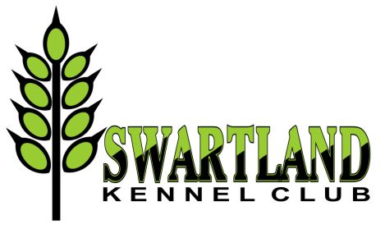 | 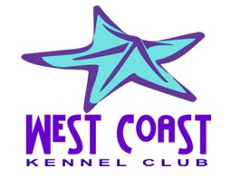 | 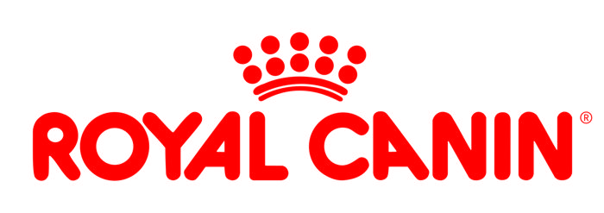
OFFICIAL SCHEDULE RIGHT OF ADMISSION RESERVED

ANOTHER POPULAR BUMPER SHOW WEEKEND
Featuring 4 Championship Shows!
Friday 21 – Sunday 23 June 2019 - Malmesbury Agricultural Show Grounds
Entries close: Monday 3 June 2019
Proof of payment must indicate payment before midnight, 3 June 2019. There will be an allowance of 2 days (until 5 June) for entries to arrive. Thereafter, entries will not be considered and there will be no refunds.

Enquiries: | Natalie Nissen: 083 925 4350 : Elrena Stadler 083 457 2659
Entry fees: | Breed: R110 per dog per class for the first 2 dogs. Thereafter R100 per dog per class.  Baby Puppy: R80 per dog  Veteran: R100 per dog  Handling classes: Free, but please note that all dogs used for handling classes need to be entered in a breed class at the same show.
Challenges:  (may also enter on the day) | Swartland Brace Sweepstake: R30 per pair.  Owner/Breeder/Handler Challenge R30 per entry
Breed classes: | Baby Puppy (4-6m)*, Minor Puppy (6-9m), Puppy (9-12m), Junior (12-18m), Graduate (18-24m), SA Bred, Veteran (7yrs+), Open, Champion. *Baby Puppy not eligible for CC or BOB
Catalogue: | Full: R150 - to be ordered and paid with entry
Payment methods: | EFT preferred or cash deposit only! No cheques, postal orders or registered mail. Please add R25 for cash deposits to cover bank charges. Entries must be accompanied with proof of payment.  Reference on deposit slip: your surname.
Instructions: | Please use a separate entry form for each show, clearly marked with the name and number of the show
Postal entries: | The Show Secretary: Malmesbury Cluster, P.O. Box 539, Edgemead. 7407
Email entries: | natb1@telkomsa.net | Faxed entries: 086 613 2517
Banking details: | Swartland Kennel Club:  First National Bank – Moorreesburg  Br code: 200111 ; EFT code: 250655  Account no: 62302944998 | West Coast Kennel Club:  First National Bank – Moorreesburg  Br code: 200111 ; EFT code: 250655  Account no: 62302937737
Commercial Stalls: | On application to Elrena Stadler – book and pay by closing date of entries. R130 per stall per day or R300 for whole weekend. Contact elrena@showdogs.co.za
Vet on Call: | Berghzicht Animal Hospital - 022 482 2399 or Emergency 079 978 3947
Show Manager: | Joy McFarlane
Order of judging: | Breed: BOB, RBOB, BP, BJ, BV, BBP; Group: BBP, BV, BJ, BP, Group  Finals: BBPIS, BVIS, BJIS, BPIS, BIS

FUN CHALLENGES
Swartland Brace | Friday 21 June | Pair two dogs of the same breed of similar appearance. Judge finds the pair (of any sex, or mixed) that works well together and looks similar.
Owner/Breeder/Handler/ Challenge | Friday 21 June | The dog being shown must have been bred by, is owned by and handled by the same exhibitor.

Only Members of the Kennel Union shall be entitled to enter dogs in their registered ownership in any Championship Dog Show licensed by the Kennel Union. All exhibitors are personally responsible for the control of their dogs at all times and shall be personally liable for any claims which may be made in respect of injuries which may arise or be caused by their dogs."

Please bee aware that the grounds are in a rural setting. Keep all sweet items and drinks covered to avoid attracting bees and wrap such refuse in plastic packets provided before disposing into litter bins.
Refreshments will be on sale. | All judging will be as per catalogue order. | Parking areas will be indicated. | Please respect the rules and Show Manager’s instructions as we would like to avail of these grounds in the future. | Exhibitors will be asked to leave the grounds if rules are not adhered to | Please clean up after your dogs and yourselves.

- Country atmosphere – country cuisine – country laid-back attitude -

***** Please take careful note of the dates and starting times of each show *****

Friday 21 June 2019 – 9.30am
Swartland KC Championship Show #2
Gundog | Herding | Hound |  | Terrier | Toy | Utility | Working
Mrs Maria Heneke | Mrs Renee Fourie | Mrs Jetty Botes |  | Mrs Leonie Kroff | Mr Adrian Sheasby | Mr Adrian Sheasby | Ms Jackie McKenzie
Judging Order: Utility will be judged first followed by Toys
On completion of all Group judging, please meet us at the Main Ring for:
Brace Challenge Sweepstakes and Owner/Breeder./Handler Challenge (Judges will be drawn on the day)
Final Stakes: BBPIS, BVIS, BJIS, BPIS, BIS
Mrs Karen Furk |  |  | Best Baby Puppy in Show; Best Veteran in Show; Best Junior in Show
 |  |  | Best Puppy in Show; Best in Show

Saturday 22 June 2019 – 8.00am
Swartland KC Championship Show #1
Gundog | Herding | Hound | Terrier | Toy | Utility | Working
Mrs Karen Furk | Mrs Maria Heneke | Ms Jackie McKenzie | Mr Lourens Ten Napel | Mrs Nicole Hartig | Mrs Renee Fourie | Mr Adrian Sheasby
First round of judging will take place in separate rings on completion of the last Group judging
On completion of the first round of judging, please meet us at the Main Ring for:
Child / Junior Handlers, judged by Ms Jackie McKenzie
Final Stakes: BBPIS, BVIS, BJIS, BPIS, BIS
Mr Lourens Ten Napel |  | Best Baby Puppy in Show |  | First round in Utility Ring; Finals in Main Ring
Ms Nicole Hartig |  | Best Veteran in Show |  | First round in Hound Ring; Finals in Main Ring
Mrs Maria Heneke |  | Best Junior in Show |  | First round in Gundog Ring; Finals in Main Ring
Mrs Renee Fourie |  | Best Puppy in Show |  | First round in Herding Ring; Finals in Main Ring
Mrs Renee Fourie |  | Best in Show |  | No first round judging
Saturday 22 June 2019 – on completion of Swartland KC Best in Show – (approx. 1.30pm)
West Coast KC Championship Show #2
Gundog | Herding | Hound | Terrier | Toy | Utility | Working
Mrs Renee Fourie | Mrs Karen Furk | Mr Adrian Sheasby | Mrs Jackie McKenzie | Mrs Anne Mason | Mrs Maria Heneke | Mrs Nicole Hartig
First round of judging will take place in separate rings on completion of the last Group judging
On completion of the first round of judging, please meet us at the Main Ring for:
Final Stakes: BBPIS, BVIS, BJIS, BPIS, BIS
Mrs Jackie McKenzie |  | Best Baby Puppy in Show |  | First round in Utility Ring; Finals in Main Ring
Mrs Renee Fourie |  | Best Veteran in Show |  | First round in Hound Ring; Finals in Main Ring
Mrs Nicole Hartig |  | Best Junior in Show |  | First round in Gundog Ring; Finals in Main Ring
Mr Adrian Sheasby |  | Best Puppy in Show |  | First round in Herding Ring; Finals in Main Ring
Mr Adrian Sheasby |  | Best in Show |  | No first round judging

Sunday 24 June 2019 – 8.30am
West Coast KC Championship Show #1
Gundog | Herding | Hound | Terrier | Toy | Utility | Working
Mrs Jackie McKenzie | Mr Adrian Sheasby | Mrs Maria Heneke | Mrs Renee Fourie | Mrs Jackie McKenzie | Mrs Nicole Hartig | Mr Lourens Ten Napel
On completion of the Group judging, please meet us at the Main Ring for:
Child / Junior Handlers, judged by Mrs Karen Furk
No pre-judging today
Final Stakes: BBPIS, BVIS, BJIS, BPIS, BIS
Mrs Renee Fourie |  | Best Baby Puppy in Show
Mr Lourens Ten Napel |  | Best Veteran in Show
Mr Adrian Sheasby |  | Best Junior in Show
Mrs Jackie McKenzie |  | Best Puppy in Show
Mrs Jackie McKenzie |  | Best in Show

GRAND BEST IN SHOW
The Best in Show winners from all four shows will compete for Grand Best in Show
Judges | Mr Adrian Sheasby, Mrs Jackie McKenzie and Mrs Renee Fourie

Thank you for supporting our shows – please travel home safely and we’ll see you again next year!
This show will be held under the Rules and Regulations of the Kennel Union of Southern Africa. The Committee reserves the right to appoint alternative judges at its discretion. Right of admission to the shows is reserved.

