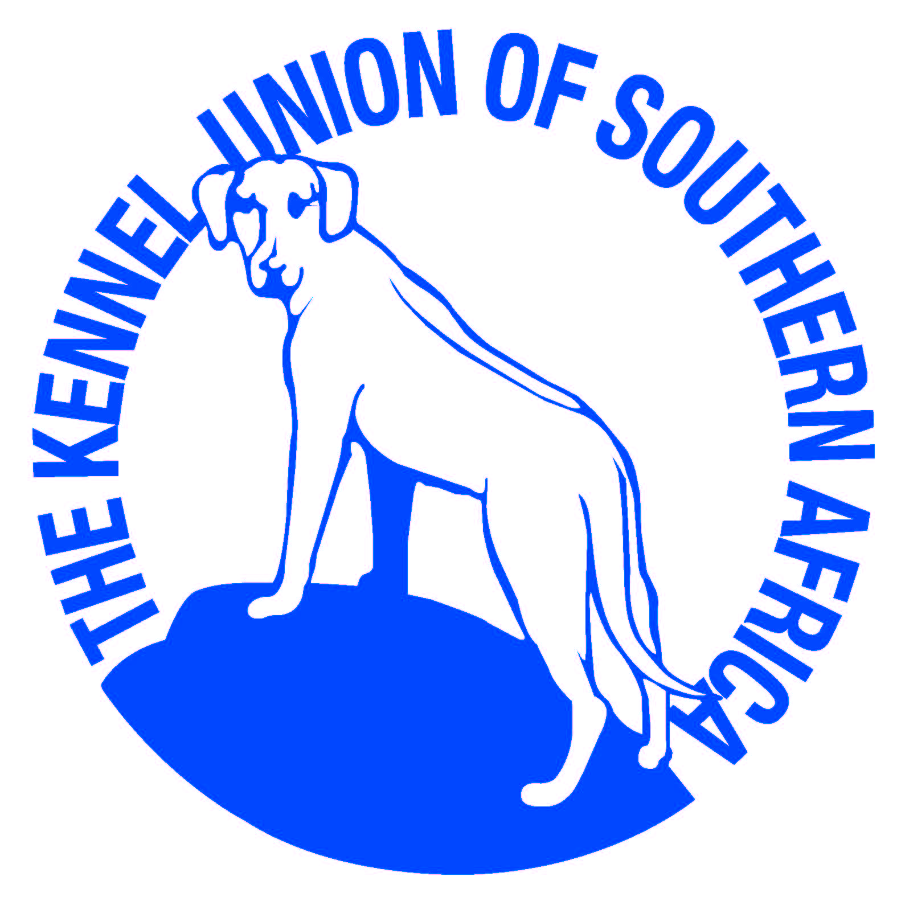

NORTHERN NATAL KENNEL CLUB
^{1ST} FCI SHOW 9/08/2019
At Ashley Sports Club, Russell Street, Pinetown
Chairman: Hans Van Rijsbergen Show Secretary: Charmayne Van Rijsbergen
Show Manager: Hans Van Rijsbergen Veterinary Surgeon: Westville Vet 031 267 8000
ENTRIES CLOSE 17thJuly 2019.
Entries post marked 17thJuly 2019 will be accepted if received within 5 days of closing date.
No substitution of dogs or change of class will be accepted.
STARTING TIMES AFTER KZNJKC CH SHOW
Only Members of the Kennel Union shall be entitled to enter dogs in their registered ownership in any Championship Dog Show licensed by the Kennel Union.

Junior Handling Gael Morison (KZN)
GROUP 1 (exc. GSD & Schipperke) Lynne Brand (KZN)
GROUP 2 Gael Morison (KZN)
GROUP 3 (exc/ Yorkshire Terr/Silky Terr/ Eng Toy Ter) Nicolet Van Rijsbergen [Hart-Davis] (KZN)
GROUP 4 Jenny Hubbard (Gauteng)
GROUP 5 Gael Morison (KZN)
GROUP 6 Jenny Hubbard (KZN)
GROUP 7 Elizabet Caminade (UK)
GROUP 8 Elizabet Caminade (UK)
GROUP 9 Gael Morison (Gauteng)
GROUP 10 Jenny Hubbard (Gauteng)
GSD; Schipperke; Yorkshire Terr/Silky Terr/Eng Toy Ter Gael Morison (KZN)
Order of Judging for Groups &
Order of Judging for BIS Classes
Best Baby Puppy in Show Gael Morison (KZN)
Best Puppy and Best Junior in Show Gael Morison (KZN)
Best in Show Gael Morison (KZN)

BREED CLASSES:
Baby Puppy, Puppy, Junior, Intermediate, Veterans, Open, Champions.
Junior Handler 11 to under 18 years (NB only this class). Proof of date of birth to be attached.
Postal entries PO Box 137 Umbogintwini 4120
Fax or email entries 086 6899 338 or mwsibra@mweb.co.za
Include copy of Bank Deposit Slip (Reference to be Owners Surname)

ALL PAYMENTS TO BE MADE OUT TO “NORTHERN NATAL KENNEL CLUB”
Bank Details FNB Hillcrest: Branch Code 223 726 Account Number 550 1114 6418
Enquires Lois Wilson Tel: 031 9034582 or 078 623 0826
Charmayne Van Rijsbergen Tel: 031 7621352 or 082 965 2477

Entry Fees Breed: R120 per class Handling: No charge
Marked Catalogue: R45 (after Show via email)

“All exhibitors/handling are personally responsible for the control of their dogs at all times and shall be personally responsible for all claims which may be made in respect of injuries which may arise or be caused by their dogs.”
The mating of bitches within precincts of the show is forbidden, bitches in season are permitted in the breed show only.
This show is held under the Rules and Regulations of the Kennel Union of Southern Africa.

RIGHT OF ADMISSION RESERVED

