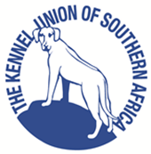
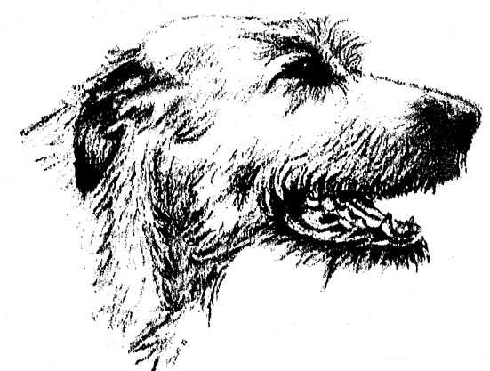

OPEN SHOW
Venue:GOLDFIELDS KENNEL CLUB GROUNDS
Lower Field, Boeing Road West, Bedfordview, Gauteng.

Sunday22ndSeptember 2019

Entries will be taken on the day of the show from 9:00am

ENTRY FEES:
R40.00 for 1st dog, or R70.00for 2 dogs and R30 per dog thereafter (per class)

JUDGING COMMENCES
at 11:00am

JUDGE:Ms Giselle Brits (Gauteng)
Ring Steward:Ms Carol Davidson

Breed Classes:*Baby Puppy (4-6mths), Minor Puppy (6-9mths), Puppy(9-12mths), Junior(12-18mths), Graduate (18-24mths), Novice, SA Bred, Veteran, Open, Champion, *Neuter Dog
(All classes eligible for Best in Show except*Baby Puppy&*Neuter Dog)

Finals: Best in Show, Reserve Best in Show, Best Puppy in Show,
Best Baby Puppy in Show, Best Neuter Dog in Show.
NB NBNB !!

10:00am: Show Handling Classto be run by
Carol Davidson
Everyone welcome especially new handlers. Learn something new, refresh old skills, but do come along….

OFFICIALS:
CHAIRMAN DAWN BARNARD
SHOW MANAGER ROGER SCOTT
SHOW SECRETARY PAT JARVIE

CONTACT:Pat Jarvie (h) 011-805 3852 (cell) 082 788 4587 e-mail: kariley@wol.co.za

Please bring your picnic or skottels & meat and stay around after
the show to socialise and celebrate the coming of Spring!

THIS SHOW/EVENT WILL BE HELD UNDER THE RULES & REGULATIONS OF THE KENNEL UNION OF
SOUTHERN AFRICA

All exhibitors / handlers are personally responsible for the control of their dogs at all times and shall be personally liable for any claims which may be made in respect of injuries which may arise or be caused by their dogs.(Refer Reg. 4.4)

The mating of bitches within the precincts of the Show is forbidden.
Puppies under four (4) months are not eligible for competition.
The committee reserves the right to appoint other judges.
All dogs are to be kept on leash at all times
Conditions attracting immediate disqualification are set out in Reg. 4 of Schedule 4 and Reg. 31 of Schedule 3

~~~~RIGHT OF ADMISSION RESERVED~~~~

