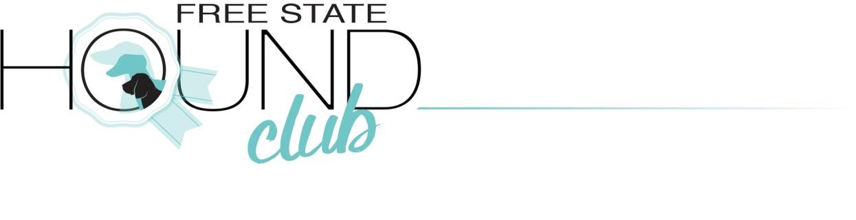
Due to COVID-19 this is the following regulations that will be followed by our club to host a dog show under LOCKDOWN ADJUSTED LEVEL 3 in South Africa.
The COVID-19 Compliance officer: Helana Taute (KUSA nr 1033521) – Tel nr 082 8287470
Deputy Officer: Paula Jarvis (KUSA nr 174579) – 084 4110417

- Our show is taking place at the sporting grounds in Frankfort with only one entry and exit gate, at this point the necessary screening will be done as well a temperature check and also an attendance register will be signed. Sanitation of hands will also be done at this point. Every person entering must wear a face mask(No face shields will be allowed). This will be applicable for all persons in a vehicle.
- Upon entry at the grounds all persons must hand in the disclaimer to obtain entry to the show
- In order to comply with the maximum of 100 people at the venue the following measures will be done:
- Only exhibitors will be allowed access to ground, all exhibitors needs to register before the start of the show and also state how many people will be travelling in their vehicle, all the people travelling in a vehicle must be registered and only persons who are exhibiting dogs at the show will be allowed to enter, no spectators , kennel hands or helpers(unless exhibiting dogs) will be allowed

- If there is more than 100 people registered there wil bel different starting times for different breeds and then exhibitors will be asked that if they are not competing for the Best in Shows to leave the grounds. This number of 100 people is inclusive of all committee members, judge, ring steward, show manager , sponsors as well as catering staff.
- The show office will be set up in such a way that social distance is maintained at all times as far as possible, clearly marked places where people can queue.
- There will be a provision of 1,5 metre walkway/no-man’s land surrounding the ring
- There will different entry and exit points for the ring.
- At the entry to ring places will be marked where exhibitors can queue before entering the ring and no crowding will be allowed at the ring entrace and only the breed that is being shown will be allowed to wait at the entry point.
- Cleary marked places isnside the ring where the line-up will take place in order to allow for social distancing.
- All exhibitors as well as the judge and ring steward will at all times be required to be wear a mask, either reusable cloth or sponge face mask, or a disposable surgical mask. Face shields are not legal, any person not wearing a mask should be asked to leave
- A sanitising station will be at the judges table and the ring steward will be required to fully sanitise the show table between exhibitors and also exhibitors will also be required to sanitise their hands before placing a dog on the table.
- The judge will use her own discretion on she will be judging the dogs in order to maintain a safe distance.
- Sanitising stations will be set all over the grounds in order to allow all persons at the venue to properly sanitise.
- The bathrooms will have an attendee to ensure it stays clean and hygienic throughout the event, this include the the cleanig of door handles. Paper towels will also be in use in the bathrooms with lined bins.
- The vendors area will also be properly marked in order for people to maintain social distancing.
- All bencing areas will be properly marked so that exhibitors will be able to maintain social distance.
- Exhibitors will be asked to keep socialising to a minimum as for everyone to feel safe and also to keep social distance.
- There will be clearly marked smoking areas, because no smoking will be allowed inside the the tent area, this is order to maintain proper ventilation at all times
- Any person not complying to the rules will be asked to leave the grounds immediately by COVID-19 compliance officers
- All persons entering the grounds will be complied to sign an indemnity form protecting the show holding club from any claims made by any person contracting COVID-19.
- Attendees should reconsider attending the event should they have comorbidities such as respiratory or heart disease, diabetes, TB , hypertension, etc
- Not attend the event if they are exhibiting any flu-like or Coronavirus symptoms.
- Advise the COVID-19 Compiance Officer if, after attending the event, they should develop any flu-like or any COVID-19 symptoms during the ensuing week.
- Attendees should bring their own chairs and sanitiser and be responsible for their personal sanitisation and the areas occupied by them

