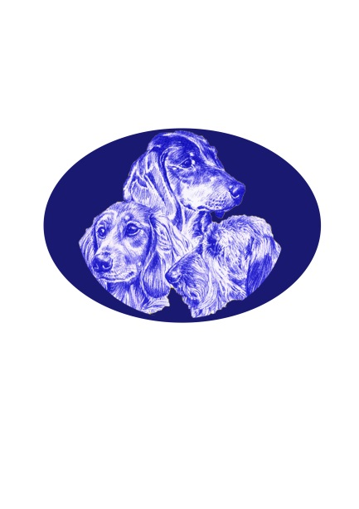
THE SOUTH AFRICAN DACHSHUND CLUB

********CHAMPIONSHIP SHOW *************
Date, Time & Venue |  | Saturday, 9th October, 202109H00  Top Field, Goldfields Show Grounds, Boeing Road, Bedfordview, Johannesburg
Breed Judge |  | MRS D LUCAS
Carting Judge |  | MRS Y. TAENTZER
Classes & Order Of Judging |  | BREED CLASSES OFFERED:  Minor Puppy, Puppy, Junior, Novice, Graduate, Members, SA Bred, Veterans, Open, Champions, Baby Puppy & Neutered Dog ORDER OF JUDGING:  BREEDS WILL BE JUDGED IN THE FOLLOWING ORDER:  Long Haired, Mini Long Haired, Smooth haired, Mini Smooth, Wire haired, Mini Wired haired.  BREED CLASSES:  On completion of all Breed classes (except Baby Puppy), Best of Breed and Reserve Best of Breed will be judged first, followed by Best Puppy, Reserve Best Puppy, Best Junior, Best Veteran Thereafter Baby Puppy Dog & Bitch classes will be judged, followed by Best Baby Puppy, followed by Neutered Dog class.  IN SHOWS :  Best Baby Puppy, Best Puppy, Best Junior, Best Veteran, Best Neuter, Best in Show  CHILD & JUNIOR HANDLING:(Dog to be entered in a breed class)will be judged before Best In Shows.
CARTING classes offered |  | Standard Novice Small : Standard Novice Large: Standard Senior Small : Standard Senior Large :
Enquiries |  | Bruce Jenkins TEL: 083 442 2552  E MAIL: waydack@worldonline.co.za FAX: 086 557 1854
Club Officials |  | Bruce Jenkins (Chairman), Charmaine Miscia (Vice Chairman & Show Manager), Petra Hüllen (Club Secretary), Matthew Batchelor (Treasurer) , Emma Buchanan (Show Secretary), Cuan Brits .(Ring Steward)
Entries | Closing Date |  | 30TH September 2021
BANKERS: |  |  | FNB ZAMBESI DRIVE BRANCH; CODE 230 145 ; ACCOUNT NO 50542199663
Entry Fees for both Breed and Carting |  | R85,00 per dog for first 2 dogs, then R75,00 for all subsequent entries in the same registered ownership. Child/Junior Handling FREE (Dog to be entered in a breed class).
(TO BE HELD UNDER GOVERNMENT COVID-19 AND SUBJECT TO LEVELS)

Veterinarian on call | Park Vet
Rules and further Announcements | - This show/event will be held under the rules & regulations of the Kennel Union of Southern Africa  - All dogs are to be kept on leash at all times.  - All exhibitors are personally responsible for the control of their dogs at all times and shall be personally liable for any claims which may be made in respect of injuries which may arise or be caused by their dogs.  - Puppies under four (4) months are not eligible for competition.  - Bitches in season will be permitted.  - The mating of bitches within the precincts of the Show is forbidden.  - The committee reserves the right to appoint other judges.  - The committee reserves the right to withdraw judging contracts...  - Conditions attracting immediate disqualification are set out in Reg. 4 of Schedule 4 and Reg. 31 of Schedule.  - Right of admission reserved.

SPONSOR:

