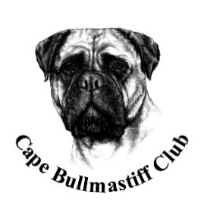

OFFICIAL SCHEDULE FOR CHARACTER & BREED ASSESSMENT SHOW FOR BULLMASTIFFS KUSA SCHEDULE 05F (9.1.11)
Affiliated to KUSA
This CBA will be held 30th October 2021
Venue: Strand High School, Sarel Cilliers Street, Strand
Time: 09h00
Judges: Nicky Robertson& Jan van Rijswijk (Breed & Character) & Chris Pretorius (Character)
All dogs entered should be 18 months or older on day of assessment and be in good health
Valid HD & ED certification from a SAVA Scrutineer & KUSA Certificate of registration required
Positive identification (Microchip) essential
Entry fees R150 per dog for members – non- members R175 (Can be paid on the day)
Documentation to be submitted before 23rd October 2021
Additional information: leather collar/ long lead/ chairs/ water / bowl
Toilet facilities limited / no catering
This CBA is only open to Bullmastiffs – time roster to be enforced – Right of Admission to be Reserved
ALL COVID LEVEL ONE REGULATIONS TO BE ADHERED TO AT ALL TIMES – MASKS/ SANITIZING/ SOCIAL DISTANCING
Show Manager& Covid Manager: Nicky Robertson # 68120
Show Secretary& Deputy Covid Manager: Ina Jenkins # 62017
ALL EXHIBITORS/ HANDLERS ARE PERSONALLY RESPONSIBLE FOR THE CONTROL OF THEIR DOGS AT ALL TIMES AND SHALL BE PERSONALLY LIABLE FOR ANY CLAIMS WHICH MAY BE IN RESPECT OF INJURIES WHICH MAY ARISE OR BE CAUSED BY THEIR DOGS
Enquires: Nicky info@capebullmastiffclub.co.za or 0829239702

