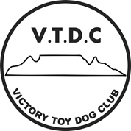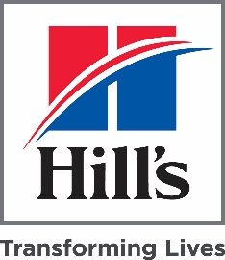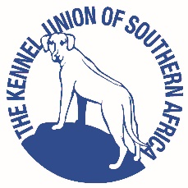

VICTORY TOY DOG CLUB
Affiliated to the Kennel Union of South Africa

NON-CHAMPIONSHIP SHOW

Judge: Jetty Botes-Erasmus Steward: TBA

DATE | SUNDAY, 30TH MAY 2021 TIME: 9H30
VENUE | SUNSHINE PET RESORT
ENTRIES | joan@rhodes.org.za Pre-Entries: Form and POP by Friday, 21/05/2021  On the day: 8H30 -9H00. (Please bring entry forms and POP to show)
ENTRY FEES | MEMBERS: R50.00 (First dog) NON-MEMBERS R60.00 (First dog), R40.00 thereafter.
BANKING DETAILS | Bank: Nedbank Account: Victory toy Dog Club A/C Number: 1186018852 Branch Code: 118602 REF: Surname & Breed
BREED CLASSES | *Baby Puppy(4-6)months, Minor Puppy(6-9)months, Puppy(9-12)months, Junior(12-18)months, Graduate(18-24)months, Veteran(+7years),Open, Champion, *Neuter
BEST IN SHOW CHALLENGES IN THIS ORDER | *Baby Puppy, *Neuter, Veteran, Junior, Puppy, Best in Show  * Not eligible for Best In Show
COMMITTEE | Show Manager: Lynn Atcheler Show Secretary: Joan Rhodes  COVID -19 OFFICER: Susan Mouton Deputy COVID-19 Officer: Les Friggens
NB: COVID-19 PROTOCOLS | Please complete the covid-19 disclaimer and hand in to the Covid-19 officer on the day. Please observe all Covid-19 protocols as attached: Masks to be worn at all times, covering nose and mouth, social distancing and sanitisation at designated points.  No spectators will be allowed: Only: Exhibitors owners, handlers and legal guardians
CATERING | TBA
VET | TBA
GENERAL INSTRUCTIONS | Bitches in season permitted  All exhibits must be on leads at all times, unless otherwise instructed by the Judge.  Breeds will be judged in alphabetical order, Appendix A of schedule 2 of the KUSA constitution.  Conditions attracting immediate disqualification are set out in regulations 7 & 31 of schedule 3.
PUBLIC LIABILITY | - All exhibitors/handlers are personally responsible for the control of their dogs at all times and shall be personally responsible for any claims which may be made in respect of injuries which may arise or be caused by their dogs.  - Any person/s responsible for any damage to the venue, grounds or irrigation system will be liable for the cost thereof.
Right of Admission reserved
KINDLY SPONSORED BY HILLS PET NUTRTION

