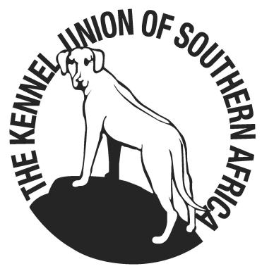
CHAMPIONSHIP SHOW SCHEDULE
10 SEPTEMBER 2022
Held under the Rules and Regulationsof the Kennel Union of Southern Africa

SPONSORED BY MONTEGO
Venue :DP de Villiers Stadium, Sasolburg
HF Verwoerd Road, Sasolburg
Time : The judging will commence at 09.00
: The contestants must be present at the venue by 08:30
Entries : R120.00 per dog per class.
Cash deposits please add R15.00 for Bank charges.
E-mail entries to nfsbullterrierclub@gmail.com
Closing date : 5 September 2022
Banking Details : Nedbank (Vaal Mall)
Account #: 107 644 2218
Branch Code: 189137 00
Catalogue : R50.00 – Please order catalogue with entry
Judge : Mr Marco van den Doel
The committee reserves the right to appoint anotherJudge
should he/she be unable to officiate.
Ring Steward : Mr L Coetzee
Enquiries : Gerhard Herbst (Chairperson) nfsbullterrierclub@gmail.com
: Lourens van Zyl (Secretary) 068 1485390
Officials : Show Manager Gerhard Herbst 083 985 2737
: Vet on Call Sasolburg Vet (Dr’s Swartz& van Wyk)

Breed Classes : Baby Puppy* (4-6m), Minor Puppy (6-9m), Puppy (9-12m), Junior (12-18m)
Graduate (18-24m), SA Bred, Veteran, Open, Champion, Neutered Dog*
* NOT ELIGIBLE FOR CC OR BOB

Challenge Classes : Best Head, Best Mover, Best Coloured, Best Substance -competitors for ...these classes. will be nominated by the judge during the show

Order of Judging : All dog breed classes, all bitch breed classes (excluding Baby Puppy), then ..Best in Show, Best Puppy in Show, Best Junior in Show, Best Veteran in ..Show, followed by Baby Puppy Dog & Bitch classes and Best Baby Puppy

General * This show is held under the Rules and Regulations of the Kennel… …………..Union of Southern Africa
* The mating of bitches within the precinct of the show is prohibited
* No animal other than an exhibit entered may be present on the show grounds
* Puppies under 4 months of age are not eligible for entry
* Theconditions in KUSA Reg 7 & 31 of schedule 3 attract immediate disqualification.
No pre-marking of space allowed.
All exhibitors, handlers, spectators and officials are responsible for the control of their dogs and children and shall be personally liable for claims made in respect of any injury or damage caused by such dogs or minors.
RIGHT OF ADMISSION RESERVED!!
Instructions:
- No faxed entries accepted.
- Ensure entries and deposit slip is clearly legible.
- No postal orders or registered mail will be accepted.
- No Cheques will be accepted.
- Include E-mail address on entry if possible.
- Numbers will not be posted – please collect at the office on day of show.
- Please bring EFT confirmation to the show in case receipt verification is required.
- No entries will be accepted unless on standard KUSA entry form with the correct fees
- No RAF & TAF entries will be accepted.
- Dogs must be always on a lead unless otherwise instructed by the Judge

