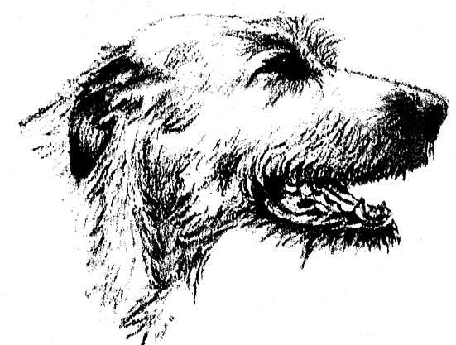
IRISH WOLFHOUND CLUB
OFGAUTENG
34th Annual ChampionshipShow
Sunday 9th April 2023
Venue: | GOLDFIELDS KENNEL CLUB, LOWER GROUNDS, ENTRANCE BOEING ROAD, BEDFORDVIEW, JOHANNESBURG, GAUTENG
Judging Starts: | 08:00 AM
JUDGE: | Ms CLAIR VAN DEN BERGH
Ring Steward: | Mrs Jenny Hubbard
Officials: | President: Mr Gérard Robinson,Patron:Mr Moss Stephenson, Patroness: Mrs Timmy Ralfe, Chairperson: Mrs Dawn Barnard, Vice-Chairperson: Mrs Ilana Erasmus, Treasurer: Mr Roger Scott, Show Manager: Mr Roger Scott
Vet on Call: | Fourways Veterinary Hospital: Tel: 011 705 3411 all hours
Enquiries: | Hon. Secretary: Mrs Julia Scott Tel - (h) 011 460 1257/ (cell) 083 515 9011
Show Entries: | Entries to be sent to:email caliburn@icon.co.za or fax to email 086 521 6389. Entries will only be accepted if sent together with proof of payment. No postal entries will be accepted.
Banking Details: | STANDARD BANK, Fourways Crossing, Branch Code 009953, Account No: 020015143. Use SURNAME as reference.
Entry Closing Date: | 27th March 2023  Entries must be submitted together with proof of payment& will be accepted if received withinfive (5) daysafter the entry closing date.
Championship Show Entry Fees: | R120 each for 1st two dogs,R100 for each subsequent dog, R80 per dog for Baby Puppy & Neuter Dog, Add R20.00 for each cash deposit to cover bank charges.
Special Classes | Special class entries will be determined by the JUDGE ON THE DAY from the dogs present. There is no entry fee. These will be entirely the judge’s choice. This is in accordance with the method used by the Irish Wolfhound Club of Ireland. Please do not leave before these classes have been judged. You will be informed by the Marshalling Steward for which classes the judge has selected your dog.
Catalogue: | R80.00,or FREE WITH four entries or more (to be ordered with entries)
Catalogue Advertising: | R100 for a full A4 page advertising your Kennel or business. Please send in your print ready advert.
Sponsorship in Catalogue: | R50 to sponsor a page. Please send in your message to the Secretary.
Membership Fees: | Due 1st May 2022. R150.00 Single, R200.00 Family.  New Membership Joining Fee of R50 to be added.
Champ Show Classes: | *Baby Puppy 4-6mths, Minor Puppy 6-9mths, Puppy 9-12mths, Junior, Graduate, Novice, S.A. Bred, Veterans, Imported, Open, Champions, *Neuter Dog. Note: *Baby Puppy and *Neuter Dog do not qualify for the CC OR Best In Show. Baby Puppies compete for Best BabyPuppy in Show and Neuter Dogs for Best Neuter Dog in Show.
Order of Finals: | Best In Show, Reserve Best In Show, Best Puppy In Show, Best Baby Puppy In Show, Best Neuter In Show
Best of Classes: | (After Championship Show judging).Dog and Bitch winners of each Championship Show class will compete against each other for "Best of Class".
Special Classes: | (Will follow judging of“Best of Classes”).Best Head & Neck, Best Movement, Height & Soundness, Best Forequarters, Best Hindquarters, Best Type.NB! ENTRIES WILL BE BY THE JUDGE’S CHOICE FROM THE DAYS JUDGING. Progeny and Brace classes will be by pre-entry (See form attached. All Special Classes will be judged at the same time.
Top 10 Parade: | (After the completion of the Special Classes.)By Invitation Only - 2022 Top Ten Irish Wolfhounds, from around the Country.
Irish Wolfhound of the Year: | 2022 Awards will follow onimmediately after the Top Ten Parade.
Trophies: | A full list of trophies will appear in the catalogue.  TROPHIES WILL NOT BE HANDED OUT AT THE SHOW – except for annual trophies. Vouchers will be given to the winnersto arrange collection. NOTE: Trophies will NOT be handed out to Non-Members.
Prizes: | To all classes; CC & RCC winners; BPIS, RBIS, BIS, BBPIS, BNIS and the Top Ten Competition winners.
Rosettes: | To all Championship Show class winners; CC & RCCwinners; BPIS,RBIS, BIS, BBPIS, BNIS; IW of the year 2022; Runner-Up IW of the Year 2022; BOS IW of the Year 2022;Puppy of the Year 2022
Sashes: | BIS, RBIS, BPIS and IW of the year 2022
Catering: | Please bring your ownpicnic basket/ refreshments.
Website: | www.irishwolfhoundclub.co.za
Facebook: | Irish Wolfhound Club – South Africa
NOTES: | - Numbers will not be posted - please collect on the day from 07:00 am.  - No RAF or TAF entries will be accepted.  - Dogs not entered in a class, or dogs entered in a class which does not exist, will automatically be entered in the OPEN CLASS.  - Puppies under the age of 4 months are not eligible for entry at this show.  - Bitches in season will be allowed, but exhibitors are requested to exercise consideration towards other exhibitors.  - The mating of bitches within the precincts of the show grounds is prohibited.  - Dogs not entered for exhibition are not permitted at the show grounds.  - No dog shall be allowed to be off a lead or benching chain unless required by the Judge.(Schedule 3, Regulation 16.2)  - The conditions stipulated in the KUSA Regulations 7 & 31 of Schedule 3 attract immediate disqualification.  - The Committee reserves the right to appoint an alternative judge should the appointed judge be unable to officiate.  - All exhibitors / handlers are personally responsible for the control of their dogs at all times and shall be personally liable for any claims which may be made in respect of injuries which may arise or be caused by their dogs. (Refer Reg. 4.4)
 | ~~~~~ RIGHT OF ADMISSION RESERVED ~~~~~

