PLEASE NOTE : ALL VEHICLES OFF THE GROUNDS BEFORE THE SHOW CAN START OR SECURITY WILL REMOVE & PLEASE DONT MARK INFRONT OF THE MEDICAL TENTS AND EMERGENCY EXIT
NO CAMPING ON THE GROUNDS IS ALLOWED

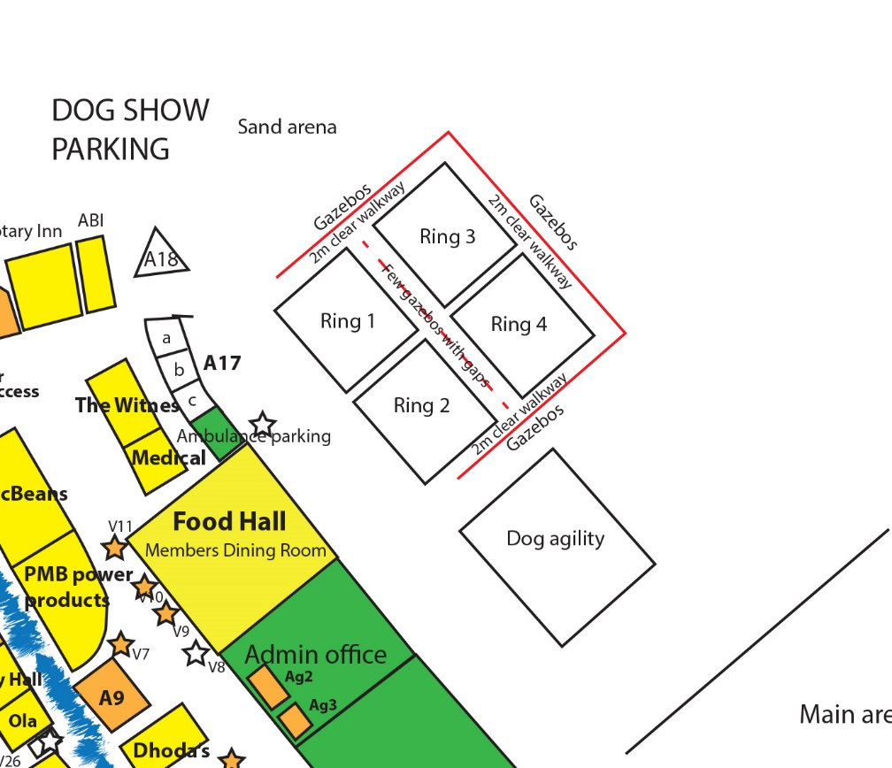JUDGES RING ALLOCATION
& RING PLAN
NB: All Finals in RING 1
FRIDAY 7TH
RING 1 – Hounds – Ann Mcdonald
RING 2 – Toys – Jill Peak
- Followed by Utility
RING 3- Herding – Bruce Jenkins
- Followed by Working
RING 4 – Gundogs- Shharat Sharma
- Followed by Terriers
SATURDAY 8TH
RING 1 – Hounds – Jill Peak
- Judged after Gundogs
RING 2 – Toys – Bruce Jenkins
- Followed by Utility - Shharat Sharma
RING 3- Working – Shharat Sharma
- Followed by Herding – Ralph Zeeman
RING 4 – Gundogs- Jill Peak
- Followed by Terriers - Bruce Jenkins
SUNDAY 9th
RING 1 – Hounds – Shharat Sharma
RING 2 – Utility – Bruce Jenkins
- Followed by Toys - Shharat Sharma
RING 3- Working – Ralph Zeeman
- Followed by Herding Jill Peak
RING 4 – Terriers - Jill Peak
- Followed by Gundogs - Bruce Jenkins

