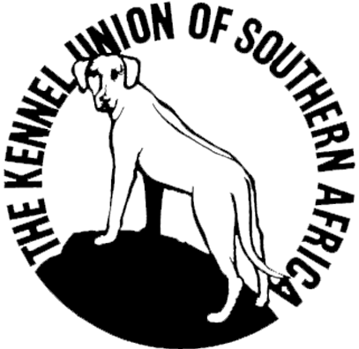KENNEL UNION OF SOUTHERN AFRICA
NATIONAL EVENT 2012 – Irene, Pretoria
Saturday 26th May 2012

PROGRAMME OF EVENTS

National Breed Eliminations – will be started after the Groups are completed at the Kusa Championship Show once the relevant Judge is available.
Judging will take place in the respective Breed Rings
National Breed Puppy – Winner of each Group
to go forward
National Dog (6 from each group selected - unplaced)
to go forward

NATIONAL EVENING AWARDS EVENT
Time of Commencement: Approximately 18h00 to 18h30 – (upon completion of the National
Eliminations – but not before 18h00)
Venue: Sax Arena, Southdowns College, Irene Pretoria
Registration: Dinner only: Please report at the side entrance to the hall to confirm your booking.
Benching: Exhibitors: Benching is provided in the foyer of the Hall. (Only entered dogs will be
allowed in the benching area and these exhibits will only be allowed into
the hall when called by the Steward.)

- Welcome address – Mr. Eva
- Acknowledgements
- Introduction of M.C
- Draw for the National Dog Referee Judge
- Introduction of Main Ring Steward
- Hound Group finals
- Toy Group finals
- Gundog Group finals
- Working Group finals
- Utility Group finals
- Herding Group finals
- Terrier Group finals
- DINNER BREAK
- National Puppy finals & Award
- National Dog finals
- Acknowledgement – National Handler Competition
- Acknowledgement – Show Manager & Main Ring Steward
- Acknowledgement – Ring Stewards
- Acknowledgement – Sponsor – ROYAL CANIN
- Announcement of 2012 Kusa Classic Weekend Venue
- National Dog 2012 announcement & Award

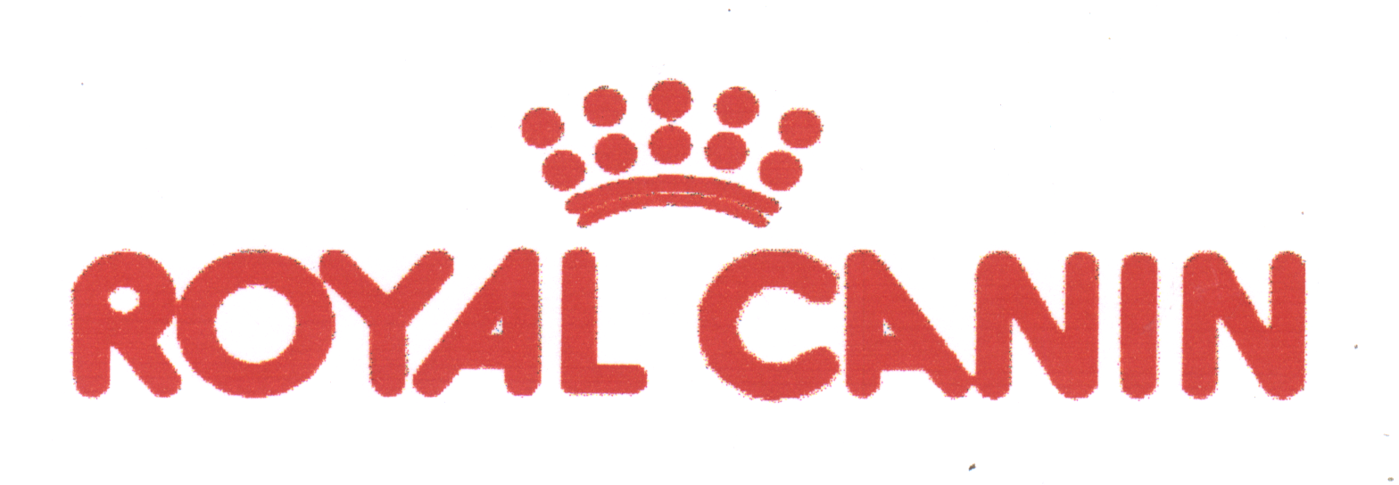On behalf of the Kennel Union of S.A. and the organising Committee, we trust that you will enjoy your evening and thank you for your support.
PROUD SPONSORS OF THE KUSA
NATIONAL AWARDS EVENTS.

