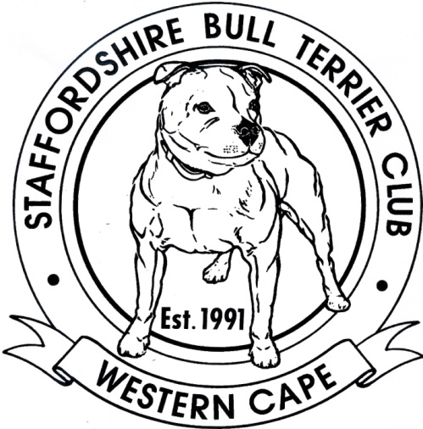

WESTERN CAPE STAFFORDSHIRE
BULL TERRIER CLUB
NON – CHAMPIONSHIP SHOW
DATE Sunday 13 September 2015
VENUE Jagtershof Rugby Club, Jagter Street, Kuilsriver

STARTING TIME Judging will commence at approx 13h00
JUDGE Johan du Toit
ENTRIES On the day from 11h30 – 12h45
Members: R40 per dog per class
Non-members: R50 per dog per class

CLASSES Baby Puppy (4-6 months) Junior (12-18 months) Veteran
Minor Puppy (6-9 months) Graduate (18-24 months) Open
Puppy (9-12 months) SA Bred Champion
PLEASE NOTE VETERANS ELIGIBLE FOR BEST DOG OR BITCH
CHAMPIONS ELIGIBLE FOR BEST OF BREED
BABY PUPPIES NOT ELIGIBLE FOR BEST OF BREED BUT WILL COMPETE
FOR BEST BABY PUPPY IN SHOW

ENQUIRIES Jason Labuschagne 0834481667 / Jumarie Knoetzen 0846215817 staffieclub@gmail.com

COMMITTEE Chairman: Mr JB Labuschagne Secretary: Miss J Knoetzen
Show Secretary: Ms T Spivak Show Manager: Mr J Hoffman

THIS SHOW WILL BE HELD UNDER THE RULES AND REGULATIONS OF THE KENNEL UNION OF SOUTHERN AFRICA
All Exhibitors/Handlers are personally responsible for the control of their dogs at all times and shall be personally liable for any claims which may be made in respect of injuries which may arise or be caused by their dogs.


