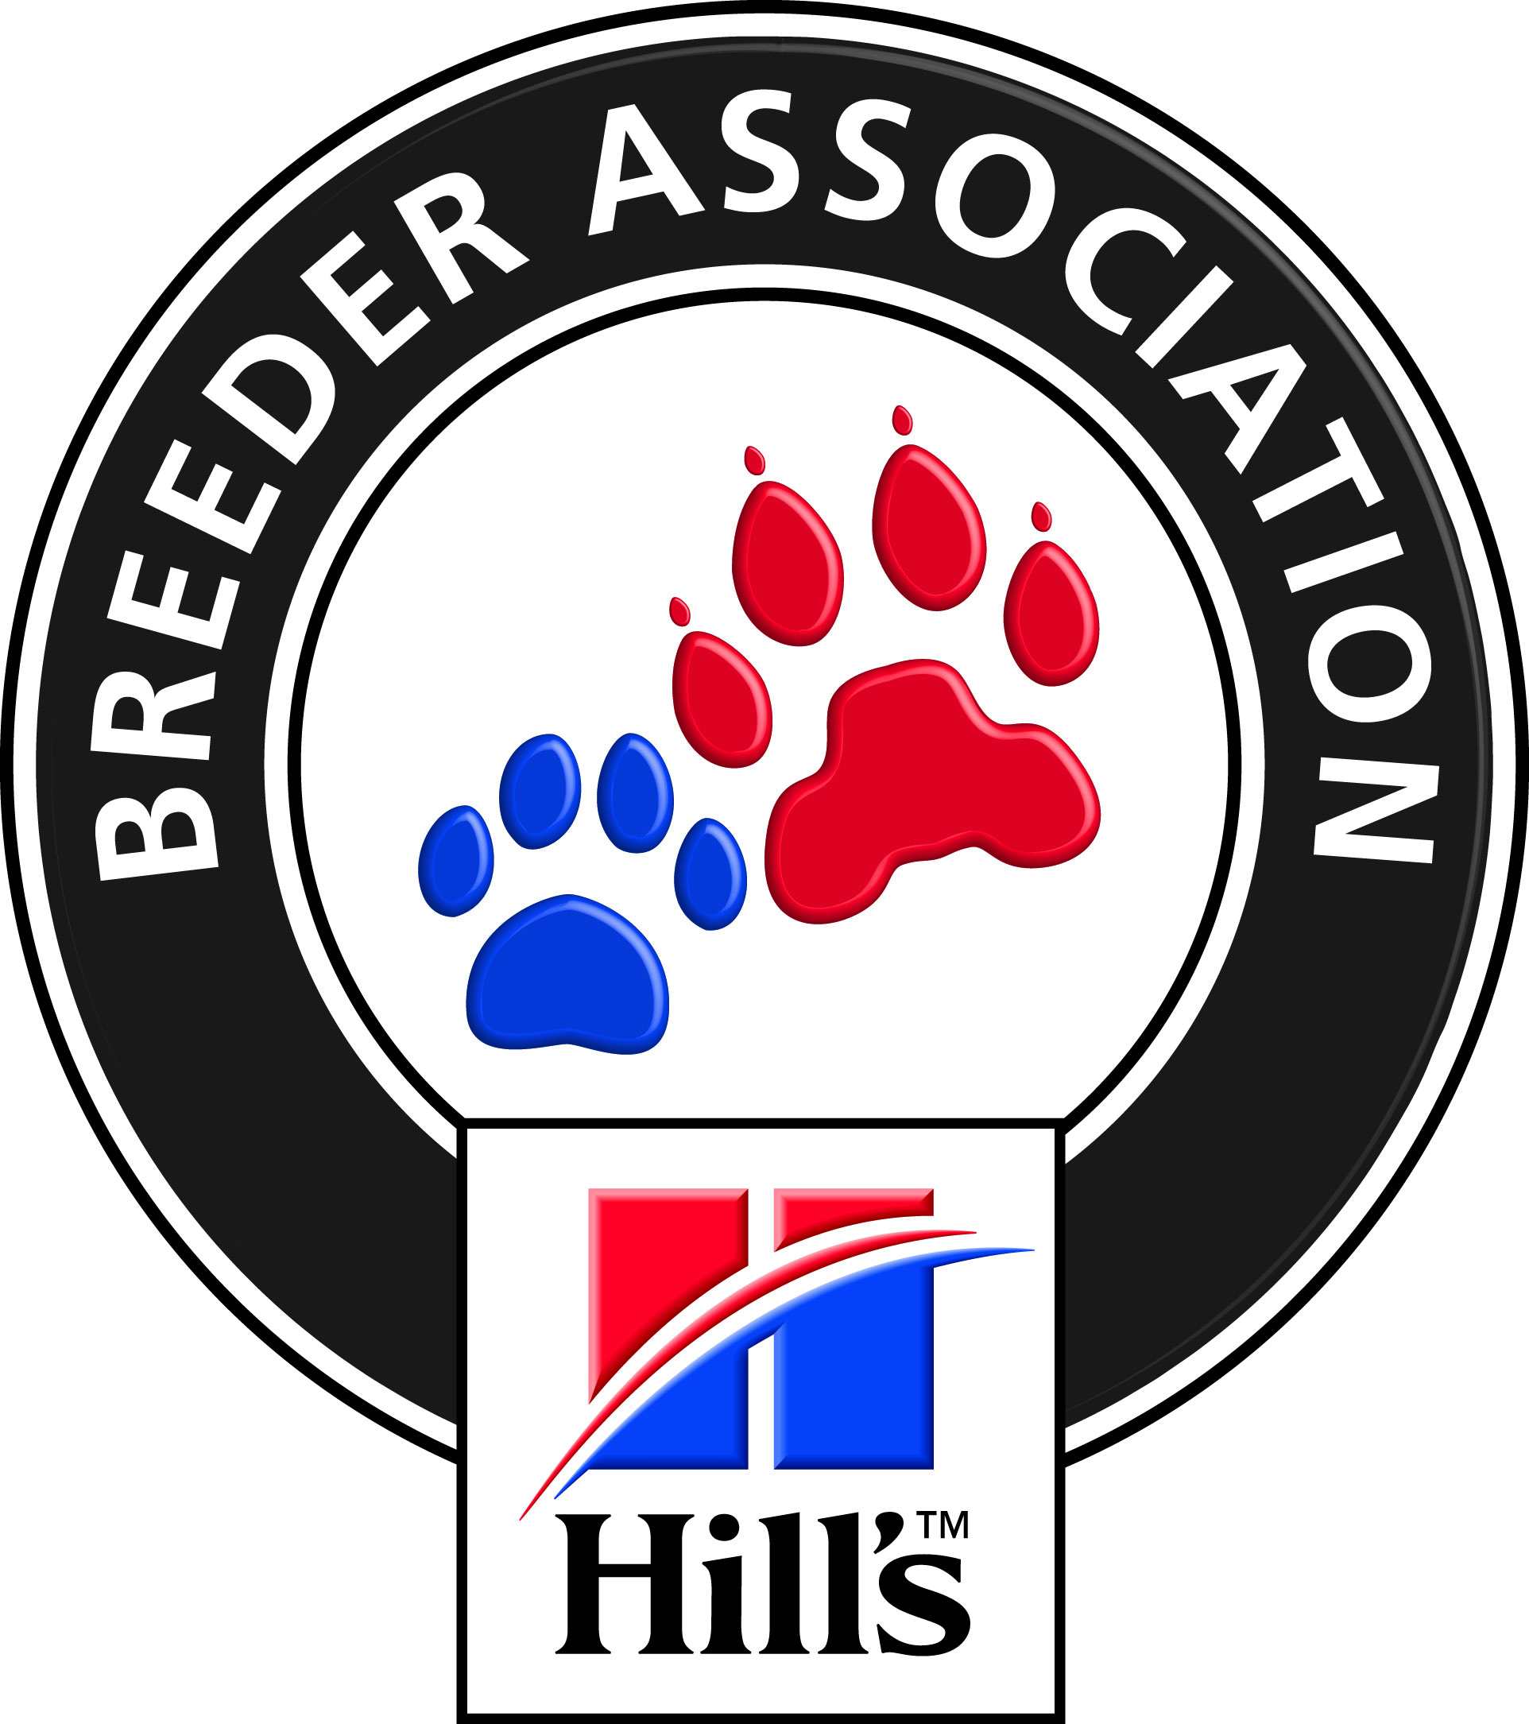

BREEDE RIVIER VALLEI KENNEL CLUB

Affiliated to the Kennel Union of Southern Africa
37th CHAMPIONSHIP SHOW
Saturday, 15 October 2016
CLOSING DATE: 26 SEPTEMBER 2016 - NO LATE ENTRIES

Venue: Kuils River Rugby Club, Jagters Street, JAGTERSHOF, Kuilsriver

Judging Times: | Flyball 8.00am  Dog Jumping /Agility 9.00 am  Breed: Hounds, Terriers and Working Groups 09:00 am  All Other Groups 10:00 am  Child & Junior Handlers: Immediately after last group finishes but not before 1:00 pm
Fees: | Breed: R 100.00 Baby Puppies and Neutered Dogs R 50.00  Child / Junior Handlers Free if the dog is entered in breed else R 100.00  Dog Jumping Grade 1,3,5 / Agility Grade 3 R 100.00  Non qualifying discipline classes R 50.00  Each additional discipline for a dog entered in any of the above R 50.00  Flyball: Team & Captain names must be on flyball entry form R 150.00  Catalogues: Group only. To be ordered and paid for with entries R 50.00  Trade stalls: To be booked and paid by 8 October 2016 R 150.00
Entries & Enquiries: | All entries MUST be accompanied by proof of payment.  Bank Reference MUST be the “Registered Owner” surname on the entry form  Money deposited will not be refunded  Secretary: Dawn Hull Address: 100 de Hulk Way, Penhill, 7100  Tel. 082 824 1422 Fax: 086 667 0983 email: brvkc@penhill.net
Banking details: | ABSA Account No: 405 793 0276 Branch Code: 334810  Please add R20 for cash or Cheque payments to cover bank charges.
Show Manager:  KUSA Representative: | Mr K HULL  Mrs D E Powell | Vet on call: Tygerberg Animal Hospital
Breed Classes: | Neuter, Baby Puppy (4 – 6 months), Minor Puppy (6 – 9 months), Puppy (9 – 12 months),  Junior (12 – 18 months), Graduate (18 – 24 months), S A Bred , Veteran (7 years +), Open and Champion
Breed judging order for groups and finals: Neuter, Baby Puppy, Puppy, Junior, Veteran, Best in Group/Show
All Breeds will be judged in alphabetical order as listed in appendix A of schedule 2 of the KUSA constitution

JUDGES
GUNDOGS | Mr JJ de A Marques | WESTERN CAPE
HERDING | Mrs A Manduell-Carkeek | KWA-ZULU NATAL
HOUNDS | Ms D C Lucas | WESTERN CAPE
TERRIERS | Ms N Vzhyshnevska | TAIWAN
TOYS | Mr D Kuzelj | BULGARIA
UTILITY All Best In Show events | Mrs G Cook | AUSTRALIA
WORKING | Mr P Chatterjee | INDIA
CHILD / JUNIOR HANDLERS | Mrs J M Musto | WESTERN CAPE
AGILITY Contact & Non-Contact - all grades | Mr M Taylor | WESTERN CAPE
OBEDIENCE Not offered as no judges are available
DOG JUMPING – TABLE A | Ms L Ball | WESTERN CAPE
FLYBALL | Ms A Minnaar | WESTERN CAPE
“All exhibitors / handlers are personally responsible for the control of their dogs at all times and shall be personally liable for any claims which may be made in respect of injuries which may arise or be caused by their dogs.” Bitches in season are allowed in Breed, Agilty & Dog Jumping
Rings will be set up by 2pm on Friday, 14TH October. Gazebos can be erected after this.

VEHICLES WILL NOT BE PERMITTED ON THE RUGBY FIELDS AT ANY TIME
RIGHT OF ADMISSION RESERVED

