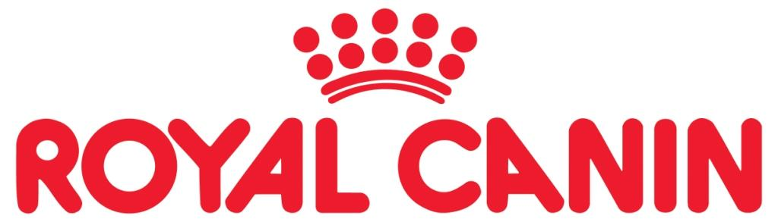

FREE STATE / VRYSTAAT

STAFFORDSHIRE BULLTERRIER

CLUB / KLUB

20 ^{th} ANNUAL CHAMPIONSHIPSHOW

RIGHT OF ADMISSION RESERVED

Date: | 26 August 2016
Time: | 18h00
Venue: | Bobbies Park Sportsgrounds  Phillips Street Fichardpark Bloemfontein
Judge: | Marius Taljaard
Ring Steward: | Ryno Rautenbach
KUSA Representative: | Mr Gawie Faul
Entry Fee: | R100-00 per dog per class.  Fee of R90/entry for 3 or more entries per handler
Catalogue: | R40-00 (to be ordered with entry)
Closing date for entries: | 14 August 2016  Entries will be accepted provided they are accompanied by the bank deposit slip. E-mail: pietkruger@vodamail.co.za
Bank details: | Free State Staffordshire Bullterrier Club  First National Bank  Branch Code: 230234 Prellerplein  Account Number: 74534119041
Address: | 86 Gen Hertzog Rd  Dan Pienaar Bloemfontein  9301
Officials: | Shari Neuhoff-de Sa (Chairman 071 683 3458)  Pieter Kruger (Show Manager 082 5789 181)  Ria van Zyl (Treasurer – 083 240 4838)
Classes: | Minor Puppy, Puppy, Junior, Graduate,  SA Bred, Open, Veterans, Champions.
Baby puppy, Neutered Dog(Not eligible for CC)
Vet on call: Dr. N Labushagne
079 1648 346
Trophies will be awarded for:
Best of Breed, Reserve Best of Breed, Best Junior, Best Puppy

All exhibitors / handlers are responsible for the control of their dogs at all times
and shall be personally responsible for any claims which may be made
in respect of injuries which may arise or be caused by their dogs.

