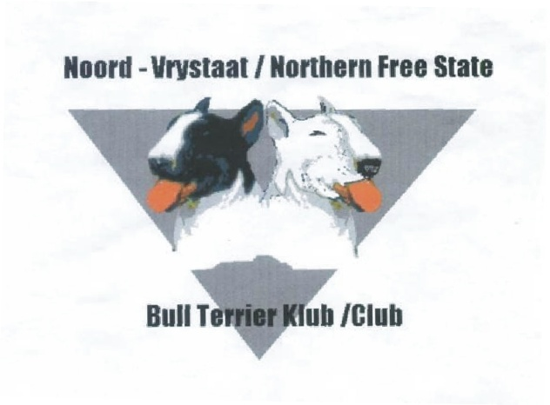

Secretary: H Pieterse
Cell: 083 796 6208

NFSbullterrierclub@gmail.com
Facebook : Nfs Bull Terrier
Chairman: LW van Zyl
Cell: 082 496 5301
nfsbullterrierclub@gmail.com

Box 63325,
Vaalpark 1928

CHAMPIONSHIP SHOW SCHEDULE, 10 SEPTEMBER 2016
Held under KUSA rules and regulations
SPONSORED BY MONTEGO CLASSIC

Venue : DP de Villiers Stadium,
: HF Verwoerd Road, Sasolburg
Time : The judging will commence at 09h00.
Entries : R100.00 per dog per class.
: Cash deposits please add R15.00 for Bank charges.
E-mail entries to nfsbullterrierclub@gmail.com
Closing date : 26August 2016
Banking Details :Nedbank (Vaal Mall)
Account: 107644 2218
Branch Code: 189137 00
Catalogue : R35.00 – Please order catalogue with entry
Judge : Mr HenkTjissen
The committee reserves the right to appoint another
Judge should the above be unable to officiate.
Ring Steward : Keanu Erasmus
Enquiries : L van Zyl(Chairman) 082496 5301
H Pieterse (Secretary) 083 796 6208
Officials : Dirk Rupping (Show Manager) 083 381 9511
Peter Nancarrow KUSA Rep
Sasolburg Vet Vet on call - Dr’sSwarts& van Wyk

Breed Classes : Baby Puppy (4-6m),Minor Puppy (6-9m), Puppy (9-12m), Junior (12-18m)
Graduate (18-24m), SA Bred, Veteran, Open, Champion, Neutered Dog,
Miniature Bull Terriers will be judged separately in the same classes.
Challenge Classes : Best Puppy, Best Head, Best Mover&Best Coloured.
General : -The mating of bitches within the precinct of the show is prohibited.
- Dogs not entered for exhibition are not permitted at the show grounds.
- The conditions in KUSA regulations 7 & 31 of schedule 3 attract immediate disqualification.
- No pre-marking space will be allowedprior to show day.
NB! – Allexhibitors, handlers, spectators and officials are responsible for the control of their dogs and children and shall be personally liable for claims made in respect of any injury or damage caused by such dogs or minors.

RIGHT OF ADMISSION RESERVED!!

Instructions:
- Emailed entries will be accepted only with proof of payment, Ref on deposit slip: your Surname, Initials and dog name(s)
- Please ensure entries and deposit slip is clearly legible.
- No postal orders or registered mail will be accepted.
- Cheques to be made out to club’s full name (not initials).
- Include E-mail address on entry if possible.
- Numbers will not be posted – please collect at the office on day of show.
- Please follow up if entries have been received if you don’t receive an email to confirmed entries.
- No entries will be accepted unless on standard KUSA entry form with the correct fees
- No RAF & TAF entries will be accepted.

