 | NORTH WEST  STAFFORDSHIRE BULL TERRIER CLUB  11th CHAMPIONSHIP SHOW  JUDGE : MR LOUIS VISAGIE  GOLDFIELDS SHOW GROUNDS  BOEING ROAD, BEDFORDVIEW  SATURDAY 13 AUGUST 2016 09H00 | 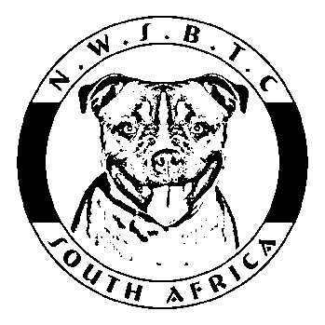

KUSA REP: To be confirmed | VET: Bedfordview Vet Hospital  (011) 616 4088 | RING STEWARD: Yvonne Sinclair

CLUB OFFICIALS: | Chairman:  Vice Chairman:  Hon Secretary:  Hon Treasurer:  Show Manager: | Johann Pretorius  Lauren Uffindell  Debbie Lurie  Stefanie Pretorius  Johann Pretorius | 076 090 5813  084 250 0622  082 822 0772  082 804 2094  076 090 5813

ENTRY FEES: | Members of NWSBTC: R 80-00 per entry registered in member’s name.  Non-members: R100-00 per entry.
CATALOGUES: | R30-00 each – to be ordered and paid for with entries.
ENTRIES CLOSE: | 29 July 2016. Numbers to be collected at the show.
POSTAL ADDRESS: | N.W.S.B.T.C., P.O. Box 650575, Benmore, 2010  Entry fees must accompany entries. All cheques must be crossed and made payable to North West Staffordshire Bull Terrier Club. No post-dated cheques will be accepted. Entries postmarked on or prior to closing date shall be accepted if received within 5 days of the closing date.  Please add R18.50 for cash or cheque deposits.
BANKING DETAILS: | ABSA Centurions Branch Code 632 005  Account Number 405 594 4174  Fax proof of deposit together with entries to 086 518 4506  or email nwsbtc@gmail.com
BREED CLASSES: | Breed classes in which exhibits may be entered and order of Judging:  Baby Puppy, Minor Puppy, Puppy, Junior, Graduate, SA Bred, Imported, Veteran, Open, Champion.
ORDER OF JUDGING: | Best Baby Puppy, Best Puppy, Reserve Best Puppy, Best Junior,  Best SA Bred, Best Veteran, Best in Show, Reserve Best in Show.
PRIZES: | Rosettes for 1^{st,} 2^{nd,} 3rd 4^{th,} CC, RCC, BBP, BP, RBP, BJ, BSAB, BV, BIS. Montego Dog Food for class winners.
CATERING: | A variety of food and drinks will be available at the kiosk on show grounds.

Photographs may be taken of dogs on the day which may be published in our newsletter and/or on our club’s FB page. Photographers (not more than two) will be nominated committee members and will enter the ring after each class has been judged to take photographs of the 1st to 4th placed dogs. Please notify the show manager if you do not want your dog to be photographed.

This Show will be held under the Rules and Regulations of the Kennel Union of S.A. All Exhibitors/Handlers are responsible for the control of their dogs at all times and shall be personally liable for any claims which may be made in respect of injuries which may arise or be caused by their dogs.

RIGHT OF ADMISSION RESERVED

