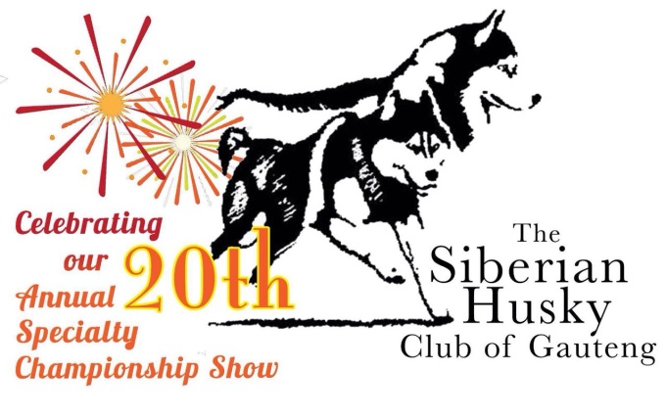
Official Schedule

CHAMPIONSHIP SHOW
Saturday, 13 August 2016

Affiliated to the Kennel Union of Southern Africa
VENUE Goldfields Showgrounds
TIME 10:00 am
JUDGE Mrs Lois Wilson
Mrs Tania Edwards
VET ON CALL Kloof Road Animal Clinic Bedfordview

ENTRY FEES R90 SPECIAL COMMEMORATIVE CATALOGUE R 50
CLOSING DATE 13 July 2016
ADDRESS P.O. Box 9. Ifafi, 0260
FAX 012 259 1530 Att: Djaki
EMAIL djakikern@yahoo.com
Faxed and e-mailed entries will only be accepted with proof of payment attached.
BANK DETAILS RLE Partridge, Standard Bank Puresave Account
Acc # 045 609 934, Branch # 051 001 00

CLASSES Baby Puppy*, Minor Puppy, Puppy, Junior, Graduate, SA Bred, Neuter*, Veteran, Open, Champion
CHALLENGES To be judged by Mrs Tania Edwards
Best Stud Dog (a male with two of his progeny)
Best Brood Bitch (a bitch with two of her progeny)
Best Brace
To enter the challenges a dog must be entered in a breed class as well

SHOW OFFICIAL Show Secretary: Miss Djaki Kern 071 355 5152
Show Manager: Mrs Anne Wilson 083 661 2427

Judging order for Best in Show:
Best Baby, Best Neuter, Best Puppy, Junior, SA Bred, Veteran, Best in Show, Challenges

Prizes proudly sponsored by:

Lots of prizes will be up for grabs thanks to our various sponsosrs & kind donations!

After the offical KUSA show is completed we will also host a FUN CLASSES!
Open to all dogs.
These can be entered on the day & include:
Cuddliest, friendliest, Best Head, Best coat, Most Unusual markings, Look-a-like dogs, fancy dress.
Only R35 per entry

Come joins us in celebarting our 20th annual championship show in style!

The show will be held according to the rules and regulations of the Kennel Union of Southern Africa.
All Exhibitors/ Handlers are personally responsible for the control of their dogs at all times and shall be personally held liable or any claims which may be made in respect of injuries which may arise or be caused by their dogs. All exhibits must be on leads at all times unless otherwise instructed by a judge. Bitches in season will be permitted.
*Baby Puppies and Neutered dogs are not eligible for the CC or BOB awards.
The Club reserves the right to appoint alternative judges should the above be unable to officiate.

Right of Admission Reserved

