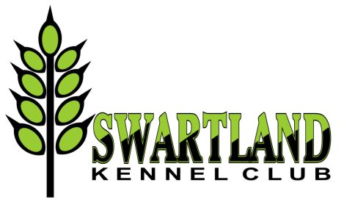

OFFICIAL SCHEDULE RIGHT OF ADMISSION RESERVED

4th CHAMPIONSHIP SHOW

Saturday 18 June 2016 – 9.00 am

Malmesbury Agricultural Show Grounds

Entries close: 1 June 2016
(absolutely no entries accepted after this date)

Enquiries: | Ms Natalie Nissen: 083 925 4350
Entry fees: | Breed: R95 per dog per class for the first two dogs. Thereafter R85 per dog per class. Baby Puppy R65 per dog per class.  Handling classes: Free if entered in breed otherwise R65 per entry.  Brace Challenge Sweepstakes: R25 - per pair.  NB: Entries and proof of payment must be received by midnight on 1 June 2016. Entries received after this date will not be considered.  Brace Challenge Sweepstakes - The Winners share the takings!
Breed classes: | Baby Puppy (4-6m), Minor Puppy (6-9m), Puppy (9-12m), Junior (12-18m), Graduate (18-24m), SA Bred, Veteran (7yrs+), Open, Champion.
Handling classes: | Child and Junior (Please complete separate entry form and supply copy of birth certificate for Child & Junior Handler classes).
Catalogue: | Full only : R85 with entry
Payment methods: | EFT preferred or cash deposit only! No cheques, postal orders or registered mail, . Please add R20 for cash deposits to cover bank charges. Entries must be accompanied with proof of payment. Reference on deposit slip: your surname.
Postal entries: | The Show Secretary: Swartland Kennel Club, P.O. Box 539, Edgemead. 7407
Email entries: | natb1@telkomsa.net
Faxed entries: | 086 613 2517
Banking details: | First National Bank – Claremont (Branch code: 200109) (EFT code: 250655)  Account: Swartland Kennel Club: 62302944998
Commercial Stalls: | On Application to Natalie Nissen – Book and Pay by closing date of entries. R100 per stall
Vet on Call: | Berghzicht Animal Hospital - 022 482 2399 or Emergency 079 978 3947
Show Manager: | Joy McFarlane

Breed classes: 9.00 am

ORDER OF JUDGING: All Groups to be judged in Alphabetical order
 | Gundog | Herding | Hound | Terrier |  | Toy | Utility | Working
 | Mrs Gael Morison | Mr Ralph Zeeman | Ms Diana Hansen | Ms Elrena Stadler |  | Mr Hans Kuilman | Mrs Lynne Brand | Mr Mervyn Heroldt
Lunch break: 12.30 – 1.15 pm
Child / Junior Handlers followed by Brace Challenge Sweepstakes to be judged during lunch break.
Judge for the Brace Challenge will be drawn on the day.

Judges: Child Handler: Ralph Zeeman / Junior Handlers: Ralph Zeeman

 | 1.15pm: Group judging resumes followed by Group finals
Final Stakes
Ms Diana Hansen |  |  |  |  | Best Baby Puppy in Show
Ms Diana Hansen |  |  |  |  | Best Veteran in Show
Ms Diana Hansen |  |  |  |  | Best Junior in Show
Mr Mervyn Heroldt |  |  |  |  | Best Puppy in Show
Mr Mervyn Heroldt |  |  |  |  | Best in Show

Please bee aware that the grounds are in a rural setting. Keep all sweet items and drinks covered to avoid attracting bees and wrap such refuse in plastic packets provided before disposing into litter bins.
Refreshments will be on sale. | All judging will be as per catalogue order. | Parking areas will be indicated. | Please respect the rules and Show Manager’s instructions as we would like to avail of these grounds in the future. | Exhibitors will be asked to leave the grounds if rules are not adhered to | Please clean up after your dogs and yourselves.
This show will be held under the Rules and Regulations of the Kennel Union of Southern Africa. The Committee reserves the right to appoint alternative judges at its discretion.

