|  |  |  |
| --- | --- | --- |
|  |  |  |

**SATURDAY, 29 OCTOBER 2016**

**GOLDFIELDS KENNEL CLUB SHOW GROUNDS,**

**Boeing Rd, Bedfordview (26" 10' 16.9S; 28" 07' 33.2E)**

**TIME**: 9:00 **ENTRY FEE: R30.00 per Stafford**

|  |  |  |
| --- | --- | --- |
| **“2015 ARMY”** | **JUDGES:**  **Steve Whitehouse (UK)**  **Christine Chatwin(UK)**  **Bianca Janssen (Neth)**  **Pieter Odendaal (SA)**  **RINGSTEWARD:**  **Marieta ten Napel** | **“2015 HOBO’S”** |

**Breed Classes: Baby Puppy* (1 class both dogs and bitches – 3-6 months), Puppy (6-12 months), Junior (12-18 months), Graduate (18-24 months), Imported (1 class both dogs and bitches), Veteran (6 years and older), SA Bred, Open & Champion**

**OTHER COMPETITIONS: BEST DRESSED TEAM, BEST “GEES”, BRAAI COMPETITION AS WELL AS CHILD AND JUNIOR HANDLING**

**COME AND JOIN US FOR A DAY FULL OF FUN AND LAUGHTER!**

**PLEASE BRING OWN MEAT, PLATES, CUTLERY, DRINKS AND GLASSES**

**RAFFLES!!!**

**Susan Kleijnhans will also do a performance with Robocop.**

**“2015 HIPPIES - FLOWER POWER”**

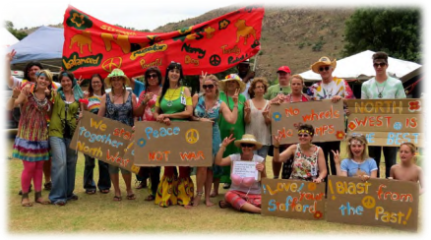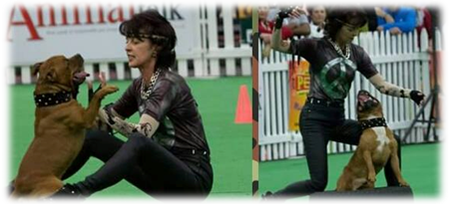

**RIGHT OF ADMISSION RESERVED**