BREEDE RIVIER VALLEI KENNEL CLUB

Affiliated to the Kennel Union of Southern Africa
NON CHAMPIONSHIP SHOW

Date: Sunday, 22 May 2016
Venue: JAGTERSHOF, Jagters Street, Kuilsriver

Judging Times: | Flyball 8.30am  Dog Jumping 9.00 am  Carting Immediately after Dog Jumping  Breed: Working Group 9:30 followed by Terriers. Other Groups 10:30  Child & Junior Handlers: Immediately after the last group is judged  before the Best in Show events.
Entry Fees  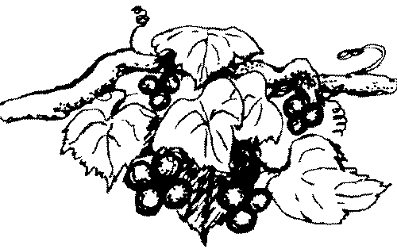 | R 50.00 per dog First discipline  R 25.00 per additional discipline – same dog  R 100.00 per Flyball team  Pre-entries to reach the Secretary by Tuesday,17 May, accompanied by proof of payment.  Please add R20 for cash or Cheque payments to cover bank charges.  Money deposited will not be refunded  Entries on the day: Taken from 7.30am until 9.30am
Entries & Enquiries: | Dawn Hull 100 de Hulk Way, Penhill, 7100  Tel. 082 824 1422 Fax: 086 517-1030  email: brvkc@penhill.net
Banking details: | ABSA Account No: 405 793 0276 Branch Code: 334810
Show Manager: | Mr K HULL
Breed Classes: | Baby Puppy (4 – 6 months) Minor Puppy (6 – 9 months)  Puppy (9 – 12 months) Junior (12 – 18 months)  Graduate (18 – 24 months) S A Bred , Veteran (7 years +), Open and Champion

Best in: VETERANS AND CHAMPIONS ARE ELIGIBLE FOR BEST OF BREED . The order of best in is

Best Baby Puppy in Show, Best Veteran in Show, Best Puppy in Show, Best Junior in Show, Best in Show

GUNDOGS | Rene Fourie | GAU
HERDING | Ken Hull | WC
HOUNDS | Sue Impey | WC
TERRIERS | Fanie van der Linde | GAU
TOYS & All Best In Show | Nicky Robertson | WC
UTILITY | Gerhard Schultz | GAU
WORKING | Fanie van der Linde | GAU
CHILD / JUNIOR HANDLERS | Sue Impey | WC
DOG JUMPING – TABLE A | L van der Merwe | WC
CARTING | L van der Merwe | WC
FLYBALL | Tinus van der Vyver | WC

PLEASE SUPPORT OUR BREED LEARNER JUDGES WITH A GOOD ENTRY

“All exhibitors / handlers are personally responsible for the control of their dogs at all times and shall be personally liable for any claims which may be made in respect of injuries which may arise or be caused by their dogs.”
Bitches in season are allowed in the Breed Ring only.

VEHICLES WILL NOT BE PERMITTED ON THE GROUNDS AT ANY TIME
RIGHT OF ADMISSION RESERVED

