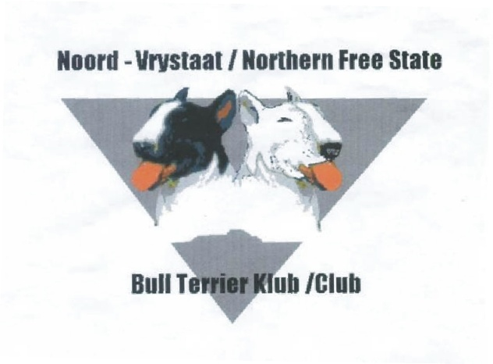
Secretary: Alta Herbst
Cell: 082 594 1711

NFSbullterrierclub@gmail.com
Facebook : Nfs Bull Terrier

Chairman: Etienne Putter
Cell: 079 881 6809
etienne.putter@gmail.com

PO Box 63325
Sasolburg
1948

CHAMPIONSHIP SHOW SCHEDULE, 8th APRIL 2017
Held under KUSA rules and regulations
SPONSORED BY MONTEGO CLASSIC

Venue : DP de Villiers Stadium, Sasolburg
HF Verwoerd Road, Sasolburg
Time : The judging will commence at 09h00.
Entries : R100.00 per dog per class.
Cash deposits please add R15.00 for Bank charges.
E-mail entries to nfsbullterrierclub@gmail.com

Closing date : 04 April 2017
Banking Details : Nedbank (Vaal Mall)
Acc: 107 644 2218
Branch Code: 189 137 00
Catalogue : R35.00 – Please order catalogue with entry
Judge : Mr Dave Brennan (ROM)
The committee reserves the right to appoint another
Judge should the above be unable to officiate.
Ring Steward : Martin la Cock
Enquiries : E Putter (Chairman) 079 881 6809 : A Herbst (Secretary) 082 594 1711
Officials : Gerhard Herbst Show Manager
Sasolburg Vet Vet on call
Dr’s Swarts & van Wyk

Breed Classes : Baby Puppy* (4-6m), Minor Puppy (6-9m), Puppy (9-12m), and Junior (12-18m)
Graduate (18-24m), SA Bred, Veteran, Open, Champion, Neutered Dog*,
Miniature Bull Terriers will be judged separately in the same classes.
*NOT ELIGIBLE FOR CC
Challenge Classes : Best Puppy, Best Head, Best Mover & Best Coloured.
General : - The mating of bitches within the precinct of the show is prohibited.
- Dogs not entered for exhibition are not permitted at the show grounds.
- The conditions in KUSA regulations 7 & 31 of schedule 3 attract immediate disqualification.
- No space may be reserved prior to show
All exhibitors, handlers, spectators and officials are responsible for the control of their dogs and children and shall be personally liable for claims made in respect of any injury or damage caused by such dogs or minors.
RIGHT OF ADMISSION RESERVED!!
Instructions:
- Faxed entries accepted only with proof of payment, Ref on deposit slip: your Surname.
- Ensure entries and deposit slip is clearly legible.
- No postal orders or registered mail will be accepted.
- Cheques to be made out to club’s full name (not initials).
- Include E-mail address on entry if possible.
- Numbers will not be posted – please collect at the office on day of show.
- Bring fax/EFT confirmation to the show in case receipt verification is required.
- No entries will be accepted unless on standard KUSA entry form with the correct fees
- No RAF & TAF entries will be accepted.

