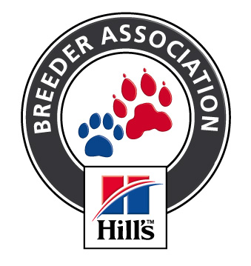 Hottentots Holland Kennel Club
H K C
H
K C
Affiliated to the Kennel Union of Southern Africa

ALL BREED NON-CHAMPIONSHIP SHOW

Date of Show : Sunday 4th June 2017
Show Venue: Brackenfell Cricket Club, Brackenfell

Starting time : approx 11.30 am
Entries from : 8.30 am on the day

Judging Times: | Breed approx 11.00am
Entry Fee: | R 50.00 per dog for Breed  R15.00 per additional class – same dog
Entries & Enquiries: | Caroline Mobile : 082-5214374 Fax: 086-7643288 or email proamacs@gmail.com  Postal : P O Box 266, Cape Gate 7562
Banking details: | Bank / branch: ABSA Durbanville  Account Name: Hottentots Holland Kennel Club  Account Number: 710631018 Code: 334712
Breed Classes: | Baby Puppy (4-6 months) /Minor Puppy (6–9months) / Puppy (9 –12months) / Junior (12– 18months) / Graduate (18 – 24 months) / S A Bred / Veteran (7 yrs +) / Open / Champions  All class winners qualify for Best of Breed. There will however be a Best Baby Puppy, Best Puppy, Best Junior and Best Veteran on Show

JUDGES
GUNDOGS and Group | Mr A Sheasby | Gauteng
HERDING and Group | Mr F Van Der Linde | Gauteng
HOUNDS – Best In Show and Best Puppy in Show | Mr F Van Der Linde | Gauteng
TERRIERS – Baby Puppy, Junior & Veteran in Show | Mr J Marques | Western Cape
TOYS | Mr R Zeeman | Western Cape
UTILITY | Mrs L Kroff | Western Cape
WORKING | Miss N Baxter | Gauteng

Order of Judging will be Baby Puppy in Show, Veteran, Junior, Puppy and BIS

- All Breeds will be judged in alphabetical order as listed in appendix A of schedule 2 of the KUSA constitution.
- All exhibitors / handlers are personally responsible for the control of their dogs at all times and shall be personally liable for
any claims which may be made in respect of injuries which may arise or be caused by their dogs.

Vehicles will be allowed onto the field to drop off trailers at designated areas and must be removed immediately

The show will not commence until every vehicle is off the field.

The person/s responsible for any damages made to the venue, grounds and /or irrigation system will be liable for the cost thereof

RIGHT OF ADMISSION RESERVED & Bitches in season will be permitted in Breed only

This Show is Sponsored by Hill Pet Nutrition

