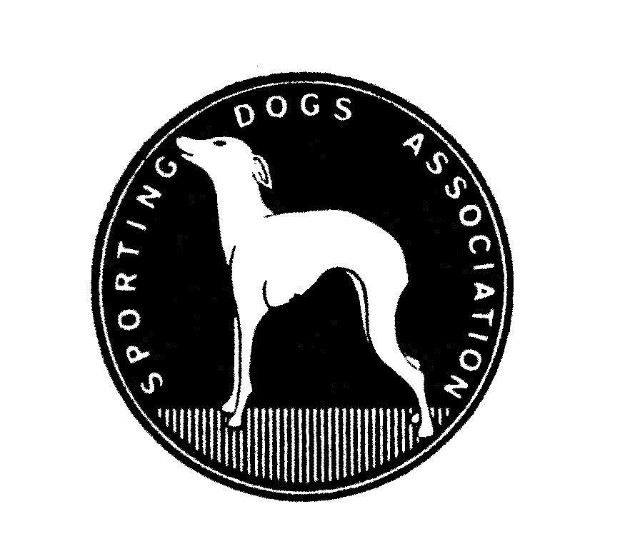

SPORTING DOGS ASSOCIATION
NON-CHAMPIONSHIP SHOW
5 MARCH 2017
Goldfields Kennel Club Showgrounds, Boeing Road, Bedfordview.

JUDGES: Fanie van der Linda
Afghan Hound, Azawakh, Basset Hound, Beagle, Bloodhound, Borzoi, Irish Wolfhound, Rhodesian Ridgeback, Saluki, Whippet.
(Excluding all Dachshunds)
Jacki Jackson
All Dachshunds

TIME: Entries taken from 09:00
Judging starts at 10:30

ENTRY FEES: R40.00 PER DOG PER CLASS

CLASSES: Baby Puppy, Minor Puppy, Puppy, Junior, Graduate, Veteran, SA Bred, Open, Champions; Neuter.
IN SHOWS: Best Puppy, Junior, Veteran, Baby Puppy, Neuter, Best in Show.

Enquiries: Jacki Jackson - 082 920 7299
Corinne Diggins - 082 859 6712

All Exhibitors are personally responsible for the control of their dogs at all times and shall be personally liable for any claims which may be made in respect of injuries which may arise or be caused by their dogs.

PLEASE NOTE THAT THE SDA HOUND OF THE YEAR WILL NOT BE HELD UNTIL FURTHER NOTICE

PLEASE SUPPORT THE FOOD KIOSK RIGHT OF ADMISSION RESERVED

