 | NORTH WEST  STAFFORDSHIRE BULL TERRIER CLUB  16th CHAMPIONSHIP SHOW  JUDGE :MRS C TALJAARD (RSA)  GOLDFIELDS SHOW GROUNDS  BOEING ROAD, BEDFORDVIEW  SATURDAY18 AUGUST 2018 10H00 | 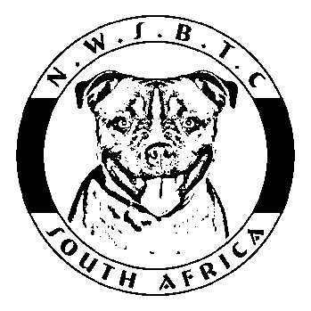

KUSA REP: To be confirmed | VET: Bedfordview Vet Hospital  (011) 616 4088 | RING STEWARD: TBA

CLUB OFFICIALS: | Chairman:  Vice Chairman:  Secretary:  Treasurer:  Show Manager: |  | Johann Pretorius  Lauren Uffindell  Stefanie Pretorius  Jackie Ortner  Brian Ortner | 076 090 5813  084 2500622  063 274 6991  083 638 6868  083 327 6767
ENTRY FEES: |  | Members of NWSBTC: R90-00 per entry.  Non-members: R110-00 per entry.
CATALOGUES: |  | R30.00 each. To be paid with entries. E-mailed copies of the marked catalogue to be requested after the show.
ENTRIES CLOSE: |  | 3 August 2018. Numbers to be collected at the show.
POSTAL ADDRESS: |  | N.W.S.B.T.C., P.O. Box 11200, Tiegerpoort, 0056  Entry fees must accompany entries. No cheques will be accepted.  Please add R20.00 for cash or cheque deposits.
BANKING DETAILS: |  | ABSA Centurion Branch Code 632 005  Account Number 405 594 4174  Proof of payment together with entries may be faxed to 086 518 4506  or email nwsbtc@gmail.com
BREED CLASSES: |  | Breed classes in which exhibits may be entered and order of Judging:  Baby Puppy, Minor Puppy, Puppy, Junior, Graduate, SA Bred, Imported, Veteran, Open, Champion.
ORDER OF JUDGING: |  | Best Baby Puppy, Best Puppy, Reserve Best Puppy, Best Junior,  Best SA Bred, Best Imported in Show, Best Veteran, Best in Show, Reserve Best in Show.
PRIZES: |  | Rosettes for 1^{st,} 2^{nd,} 3rd 4^{th,} CC, RCC, BBP, BP, RBP, BJ, BSAB, BIIS, BV, BIS, RBIS. Montego Dog Food for class winners.
CATERING: |  | Free tea and coffee will be available before the show.

Photographs may be taken of dogs on the day which may be published in our newsletter and/or on our club’s FB page. Photographers (not more than two) will be nominated committee members and will enter the ring after each class has been judged to take photographs of the 1st to 4th placed dogs. Please notify the show manager if you do not want your dog to be photographed.

This Show will be held under the Rules and Regulations of the Kennel Union of S.A. All Exhibitors/Handlers are responsible for the control of their dogs at all times and shall be personally liable for any claims which may be made in respect of injuries which may arise or be caused by their dogs.
RIGHT OF ADMISSION RESERVED

