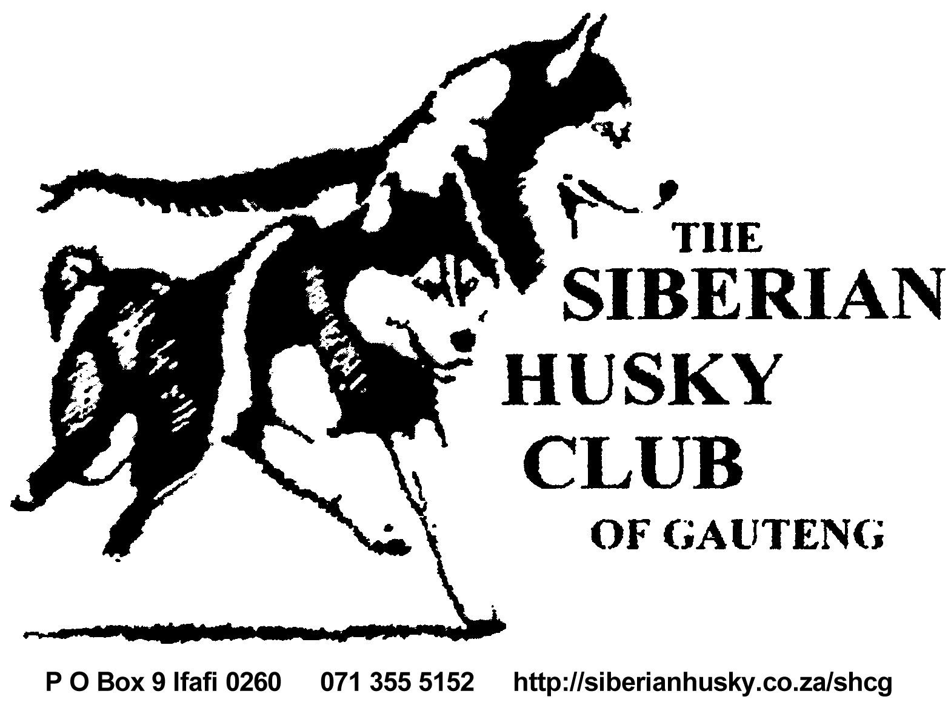Official Schedule

CHAMPIONSHIP SHOW
Sunday, 15 July 2018

Affiliated to the Kennel Union of Southern Africa
VENUE Goldfields Showgrounds
TIME After Gundog Group (EDKC)
JUDGE Mrs G Cook (Aus)
VET ON CALL Kloof Road Animal Clinic Bedfordview

ENTRY FEES R95 CATALOGUE R 35
CLOSING DATE 15 June 2018
ADDRESS P.O. Box 9. Ifafi, 0260
FAX 012 259 1530 Att: Djaki
EMAIL djakikern@yahoo.com
Faxed and e-mailed entries will only be accepted with proof of payment attached.
BANK DETAILS RLE Partridge, Standard Bank Puresave Account
Acc # 045 609 934, Branch # 051 001 00

CLASSES Baby Puppy*, Minor Puppy, Puppy, Junior, Graduate, SA Bred, Neuter*, Veteran, Open, Champion
CHALLENGES Best Stud Dog (a male with two of his progeny)
Best Brood Bitch (a bitch with two of her progeny)
Best Brace
To enter the challenges a dog must be entered in a breed class as well

SHOW OFFICIAL Show Secretary: Miss Djaki Kern 071 355 5152
Show Manager: Mr Duane Tiquin

The show will be held according to the rules and regulations of the Kennel Union of Southern Africa.
All Exhibitors/ Handlers are personally responsible for the control of their dogs at all times and shall be personally held liable or any claims which may be made in respect of injuries which may arise or be caused by their dogs. All exhibits must be on leads at all times unless otherwise instructed by a judge. Bitches in season will be permitted.
*Baby Puppies and Neutered dogs are not eligible for the CC or BOB awards.
The Club reserves the right to appoint alternative judges should the above be unable to officiate.

Right of Admission Reserved
Prizes proudly sponsored by:

