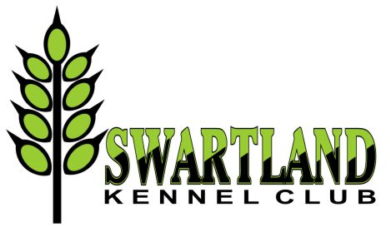 | 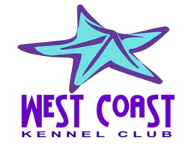 | 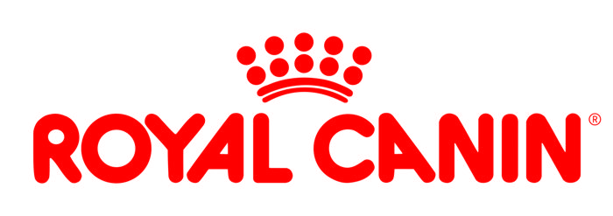
OFFICIAL SCHEDULE RIGHT OF ADMISSION RESERVED

ANOTHER POPULAR BUMPER SHOW WEEKEND
Featuring 4 Championship Shows!
Friday 22 – Sunday 24 June 2018 - Malmesbury Agricultural Show Grounds
Entries close: 5 June 2018
Proof of payment must indicate payment before midnight, 5 June 2018. There will be an allowance of 2 days (until 7 June) for entries to arrive. Thereafter, entries will not be considered and there will be no refunds.

Enquiries: | Natalie Nissen: 083 925 4350 : Elrena Stadler 083 457 2659
Entry fees: | Breed: R110 per dog per class for the first 2 dogs. Thereafter R90 per dog per class.  Baby Puppy: R70 per dog  Veteran: R90 per dog  Handling classes: Free if entered in breed otherwise R70 per entry.
Challenges:  (may also enter on the day) | Swartland Brace Sweepstake: R20 per pair.  Designer Dog Sweepstake : R10 per entry |  | The winners share the takings!
Breed classes: | Baby Puppy (4-6m)*, Minor Puppy (6-9m), Puppy (9-12m), Junior (12-18m), Graduate (18-24m), SA Bred, Veteran (7yrs+), Open, Champion. *Baby Puppy not eligible for CC or BOB
Catalogue: | Full: R130 - to be ordered and paid with entry
Payment methods: | EFT preferred or cash deposit only! No cheques, postal orders or registered mail. Please add R25 for cash deposits to cover bank charges. Entries must be accompanied with proof of payment.  Reference on deposit slip: your surname.
Instructions: | Please use a separate entry form for each show, clearly marked with the name and number of the show
Postal entries: | The Show Secretary: Malmesbury Cluster, P.O. Box 539, Edgemead. 7407
Email entries: | natb1@telkomsa.net | Faxed entries: 086 613 2517
Banking details: | Swartland Kennel Club:  First National Bank – Moorreesburg  Br code: 200111 ; EFT code: 250655  Account no: 62302944998 | West Coast Kennel Club:  First National Bank – Moorreesburg  Br code: 200111 ; EFT code: 250655  Account no: 62302937737
Commercial Stalls: | On application to Natalie Nissen – book and pay by closing date of entries. R120 per stall per day or R300 for whole weekend
Vet on Call: | Berghzicht Animal Hospital - 022 482 2399 or Emergency 079 978 3947
Show Manager: | Joy McFarlane
Order of judging: | Breed: BOB, RBOB, BP, BJ, BV, BBP; Group: BBP, BV, BJ, BP, Group  Finals: BBPIS, BVIS, BJIS, BPIS, BIS

! ! THE SWEEPSTAKES ! !
Swartland Brace | Friday 22 June | Pair two dogs of the same breed of similar appearance. Judge finds the pair (of any sex, or mixed) that works well together and looks similar.
Designer Dog | Sunday 24 June | You may be hoping to make up a champion - how about you make a dog?!!!  Create a Designer Dog of any shape and size for this challenge using recycled items (eg. cardboard tubes, plastic containers, cans, bottles, boxes, etc) put together with string, tape, wire, glue, etc., and add a touch of breed features with paint, buttons, wool, fibre, wood shavings, plastic, etc. Let your imagination flow to create the perfect Designer Dog; identify the “breed” and give it a name; then have it ready for judging on Sunday at lunchtime.

Please bee aware that the grounds are in a rural setting. Keep all sweet items and drinks covered to avoid attracting bees and wrap such refuse in plastic packets provided before disposing into litter bins.
Refreshments will be on sale. | All judging will be as per catalogue order. | Parking areas will be indicated. | Please respect the rules and Show Manager’s instructions as we would like to avail of these grounds in the future. | Exhibitors will be asked to leave the grounds if rules are not adhered to | Please clean up after your dogs and yourselves.

- Country atmosphere – country cuisine – country laid-back attitude -

***** Please take careful note of the dates and starting times of each show *****

Friday 22 June 2018 – 9.30am
Swartland KC Championship Show #2
Gundog | Herding | Hound |  | Terrier | Toy | Utility | Working
Ms Dale  Fabian | Mr Greg  Eva | Mr Fanie van der Linde |  | Mr Trevor Hiscock | Mr Rion van der Linde | Mrs Avril Ventress | Mr Gunnar Nymann (Den)
On completion of all Group judging, please meet us at the Main Ring for:
Brace Challenge Sweepstakes (Judge will be drawn on the day)
Final Stakes: BBPIS, BVIS, BJIS, BPIS, BIS
Mr Fanie van der Linde |  |  | Best Baby Puppy in Show; Best Veteran in Show; Best Junior in Show
Mr Trevor Hiscock |  |  | Best Puppy in Show; Best in Show

Saturday 23 June 2018 – 8.00am
Swartland KC Championship Show #1
Gundog | Herding | Hound | Terrier | Toy | Utility | Working
Mr Gunnar Nymann (Den) | Mrs Avril Ventress | Ms Helen Theron | Mrs Liz Raubenheimer | Mr Fanie van der Linde | Mrs Janet  Wang | Mrs Rose-Marie Cabion
Pre-judging of the Finals will take place in separate rings on completion of the last Group judging
On completion of pre-judging, please meet us at the Main Ring for:
Child / Junior Handlers, judged by Mrs Liz Raubenheimer
Final Stakes: BBPIS, BVIS, BJIS, BPIS, BIS
Mrs Avril Ventress |  | Best Baby Puppy in Show |  | Pre-judging in Utility Ring; Finals in Main Ring
Mrs Janet Wang |  | Best Veteran in Show |  | Pre-judging in Hound Ring; Finals in Main Ring
Mr Trevor Hiscock |  | Best Junior in Show |  | Pre-judging in Gundog Ring; Finals in Main Ring
Mr Gunnar Nymann (Den) |  | Best Puppy in Show |  | Pre-judging in Herding Ring; Finals in Main Ring
Mr Gunnar Nymann (Den) |  | Best in Show |  | No pre-judging
Saturday 23 June 2018 – on completion of Swartland KC Best in Show – (approx. 1.30pm)
West Coast KC Championship Show #2
Gundog | Herding | Hound | Terrier | Toy | Utility | Working
Mrs Juliette Duthie | Mr Trevor Hiscock | Mr Rion van der Linde | Mrs Avril Ventress | Mr Gunnar Nymann (Den) | Mrs Rose-Marie Cabion | Mrs Janet  Wang
Pre-judging of the Finals will take place in separate rings on completion of the last Group judging
Final Stakes: BBPIS, BVIS, BJIS, BPIS, BIS
Mr Trevor Hiscock |  | Best Baby Puppy in Show |  | Pre-judging in Utility Ring; Finals in Main Ring
Mrs Avril Ventress |  | Best Veteran in Show |  | Pre-judging in Hound Ring; Finals in Main Ring
Mrs Janet Wang |  | Best Junior in Show |  | Pre-judging in Gundog Ring; Finals in Main Ring
Mrs Rose-Marie Cabion |  | Best Puppy in Show |  | Pre-judging in Herding Ring; Finals in Main Ring
Mrs Rose-Marie Cabion |  | Best in Show |  | No pre-judging

Sunday 24 June 2018 – 8.30am
West Coast KC Championship Show #1
Gundog | Herding | Hound | Terrier | Toy | Utility | Working
Mr Trevor Hiscock | Mrs Caroline Gilmour | Mr Gunnar Nymann (Den) | Mr Rion van der Linde | Mrs Stephenette du Toit | Mrs Liz Raubenheimer | Mrs Avril Ventress
On completion of the Group judging, please meet us at the Main Ring for:
Child / Junior Handlers, judged by Mrs Stephenette du Toit
And then some fun and games….. The Designer Dog Sweepstake!
Final Stakes: BBPIS, BVIS, BJIS, BPIS, BIS
Mr Gunnar Nymann (Den) |  | Best Baby Puppy in Show; Best Veteran in Show; Best Junior in Show
Mrs Avril Ventress |  | Best Puppy in Show; Best in Show

GRAND BEST IN SHOW
The Best in Show winners from all four shows will compete for Grand Best in Show
Judges | Mr Gunnar Nymann (Den) & Mrs Caroline Gilmour
Referee | Mr Trevor Hiscock

Thank you for supporting our shows – please travel home safely and we’ll see you again next year!
This show will be held under the Rules and Regulations of the Kennel Union of Southern Africa. The Committee reserves the right to appoint alternative judges at its discretion.

