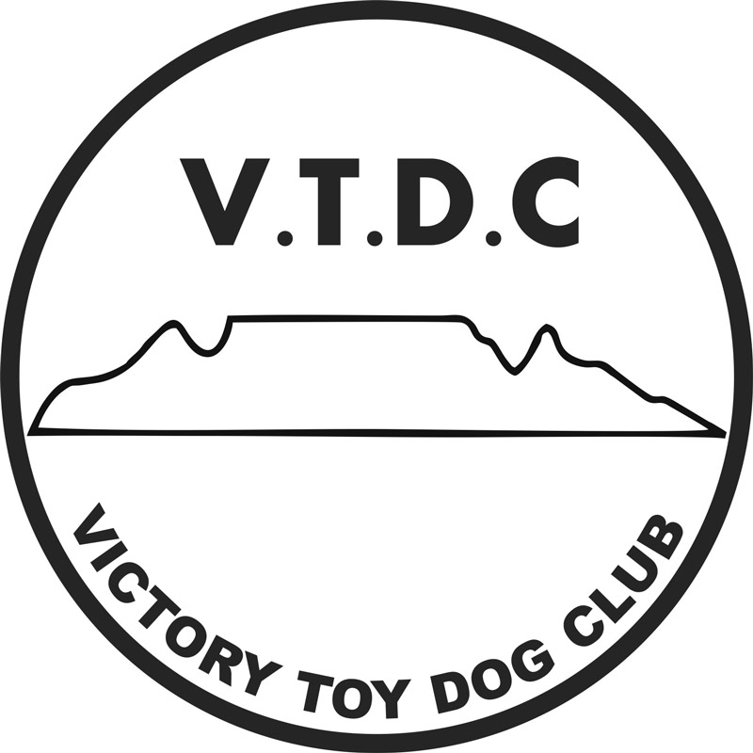 VICTORY TOY DOG CLUB
CHAMPIONSHIP SHOW
(Show 2)

DATE: Friday, 26thOctober 2018
VENUE: Brackenfell Sports Club, Witels Rd, Brackenfell.

ENTRIES CLOSE: 18th October 2018 (NO LATE ENTRIES WILL BE ACCEPTED)

STARTING TIME: BREED: 30 mimutes after final judging of CUDC. (approx. 13h30)
ENQUIRIES: Joan Rhodes Cell: 0832302518 or 021 7946955 Email: joan@rhodes.org.za
OFFICIALS: Show Manager: Judith Musto Secretary: Joan Rhodes

ENTRY FEES: Early Entries Received by the 11th October 2018.
R120.00 per dog per class: (Non-members)

Members VTDC: R100.00 per dog per class
Baby Puppies: R80.00 (members and non-members)

Entries received , 12-18th October 2018
R150.00 per dog per class.
Baby Puppies: R100.00 per dog per class

ENTRIES TO: Entry form and proof of payment must be emailed together to: Email: joan@rhodes.org.za

BANKING DETAILS: Nedbank – branch code: 118 602
Account number: 11860 18852

BREED CLASSES: Baby puppy (4-6 mths)*, Minor puppy (6-9 mths) Puppy (9-12 mths), Junior (12-18 mths),
Graduate (18-24 mths), SA Bred, Veteran (7 yrs+), Open, Champion, Neuter*

- *Not eligible for CC or BOB
- Bitches in season permitted.
- All exhibits must be on leads at all times, unless otherwise instructed by a Judge.

CHALLENGES: Best Baby Puppy*, Best Neuter*, Best Puppy, Best Junior, Best Veteran, Best in Show

JUDGE: Mr D. Manton RING STEWARD: TBA Ring Marshall: Roslyn Walton

Public Liability:
- All exhibitors/handlers are personally responsible for the control of their dogs at all times and shall be personally liable for any claims which may be made in respect of injuries which may arise or be caused by their dogs.
- Any person/s responsible for any damage to the venue, grounds or irrigation system will be liable for the cost thereof.

Vet on call: Tygerberg Animal Hospital Tel: 0219191191

Right of admission reserved

