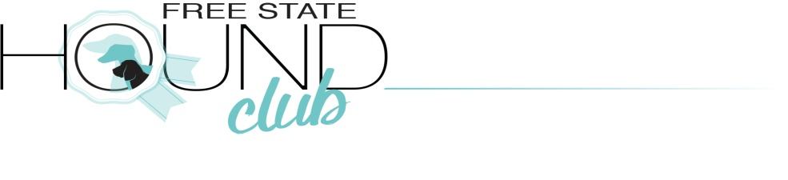
2nd Open Show proudly sponsored by

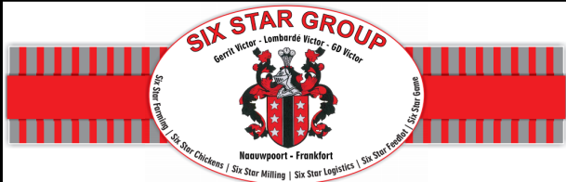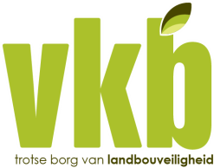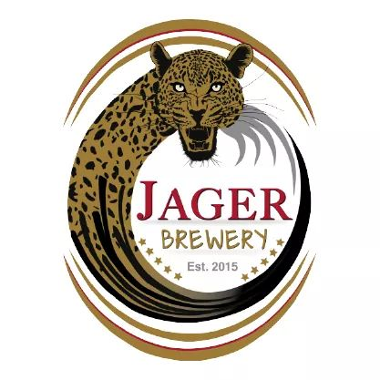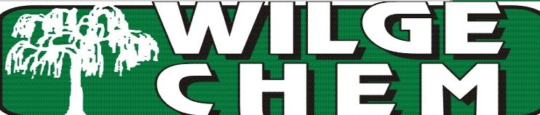
10.00am 3rd November 2018
Entries – From 9.00 on the day
Judge – Mr Kevin Young - Gauteng

Venue – GH Human Sport grounds, Church Street, Frankfort, Free State – Right of admission reserved
Benching- Indoor& outdoor undercover benching available, no gazebos needed. The show will take place in a marquee tent.
Breed Classes – Minor Puppy, Puppy, Junior, Graduate, Veteran, SA Bred, Open, Champions.
Baby Puppy & Neutered Dog after BOB & not eligible for BOB.
Entry fees – Breed classes R40 per dog, Baby Puppy & Neutered Dog R30
- Members R40 per dog for first 2 dogs then R30 per dog
Catering - Catering& full bar available at the venue.

Enquiries – 0824558860 or 0828287470, email - freestatehoundclub@gmail.com
Officials – Chairman/Sec:J Taute, Hon Treasurer :H Taute,
Vet on Call Frankfort Diere Kliniek 058 813 1044

This show is held under KUSA rules & regulations. The committee reserves the right to appoint an alternative judge if necessary. It is the responsibility of the exhibitor to ensure that dogs are under control at all times and shall be personally liable for all claims which may arise through damage or injury thereby. All dogs must be kept on leads at all times. Bitches in season are allowed but due consideration must be given by handlers to other dogs in the ring & surrounds. Right of admission reserved.

