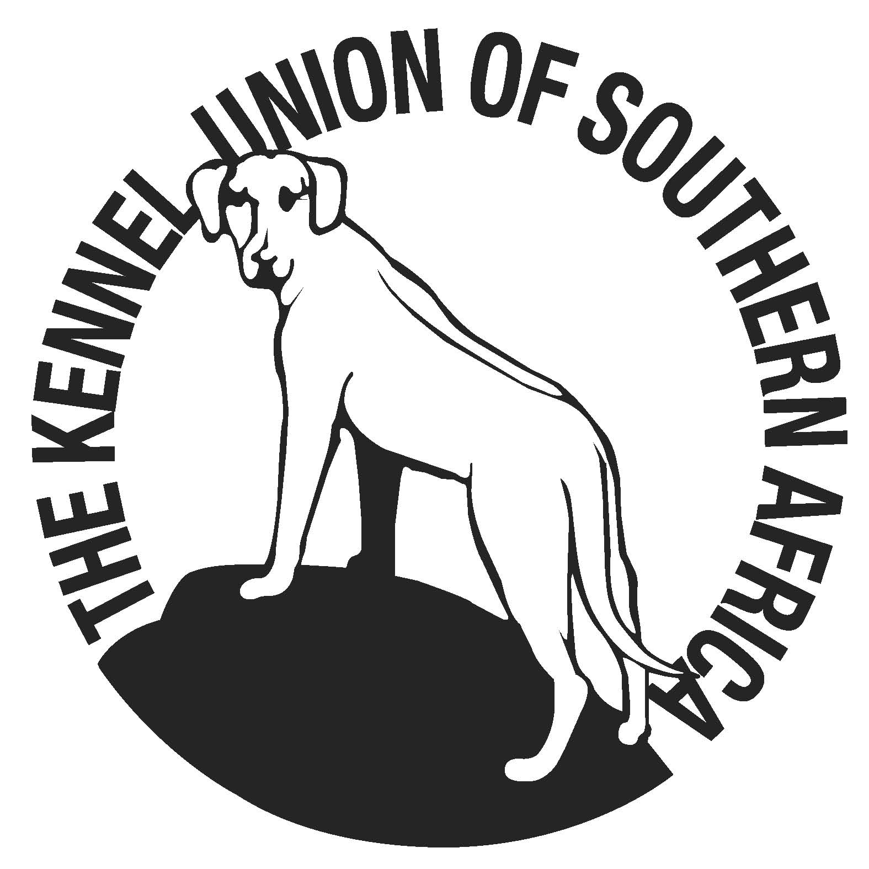

THE SOUTH AFRICAN DACHSHUND CLUB
OPEN SHOW
(Held under the Rules & Regulations of KUSA)

SUNDAY 3rdFebruary 2019
AT GOLDFIELDS KENNEL CLUB GROUNDS
BOEING ROAD, BEDFORDVIEW

Enquiries to: Tel: 083 442 2552 or email waydack@worldonline.co.za

Time: Entries from 08H30 Judging starts at 10H00

Entry Fees: R40.00 FOR 1ST 2 ENTRIES THEN R30,00 PER EACH SUBSEQUENT ENTRY

Judge: MS N. REDTENBACHER

Ring Steward T.B.A.

Classes: Minor Puppy, Puppy, Junior, Graduate, Veterans, SA Bred, Open,
Champions, Baby Puppy (4-6mths),Neutered Dog,

BEST IN SHOW BABY PUPPY, BEST IN SHOW PUPPY, BEST IN SHOW JUNIOR, BEST IN SHOW VETERAN, BEST IN SHOW NEUTERED DOG & BEST IN SHOW.

All exhibitors/handlers are personally responsible for the control of their dogs at all times and shall be personally liable for any claim in respect of injuries, which may be caused by their dogs. Bitches in season are permitted, but consideration to be given to exhibitors.
RIGHT OF ADMISSION RESERVED

THIS SHOW IS SPONSORED BY
JUAVA DOG FOOD

PLEASE NOTE THIS SHOW IS BACK TO BACK WITH TECKEL CLUB FOR YOUR CONVENIENCE!
SUPPORT YOUR CLUBS!

