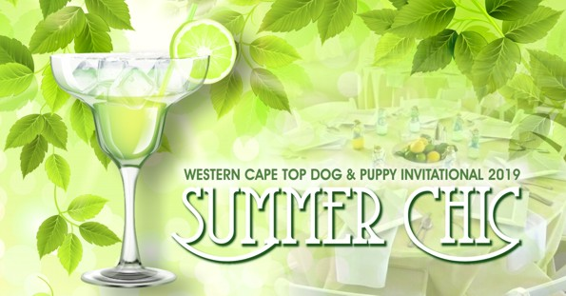

This prestigious Annual Invitational Event will be held at

Malmesbury Agricultural Show Grounds

Saturday 7 December 2019 : Time: 9.30 am
(Puppies to be present by 9.00 am)
Judges:
Puppy Stake – Mrs Nicky Robertson (WC)
Adult Stakes – Mr Michael Vorster (KZN)

Light Brunch & Summer Luncheon – R220 per person

(Puppy/dog entry is by invitation, but guest attendance is very welcome)

Enquiries: Elrena Stadler elrena@showdogs.co.za

