BOXER CLUB GOLF REEF
NON-CHAMPIONSHIP SHOW
Held under the rules and regulations of the Kennel Union of Southern Africa

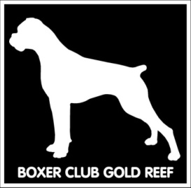
SUNDAY: 23 FEBRUARY 2020
VENUE: Goldfields Show grounds, Boeing West,
BEDFORDVIEW

JUDGING: 10h00

JUDGE: MRS SALLY YOUNG (GAUTENG)

CLASSES:
*Baby Puppy, Minor Puppy, Puppy, Junior, Graduate, SA Bred, Veterans, Open, Champions, *Neutered, *White Boxers
BEST IN SHOW, RES BEST IN SHOW, BEST PUPPY, BEST JUNIOR, BEST SA BRED, BEST VETERAN, BEST BABY PUPPY, BEST NEUTERED
Puppies under 4 months not eligible for exhibition. Bitches in season will be allowed in the Breed Classes, but please have due consideration for the other competitors. Mating of bitches within the precincts of the show is forbidden.
*Not eligible for BIS

Entries from 9h00
ENTRY FEE: R 50.00 per dog per class

Enquiries: Erna Faber 082 749 3275
maroelani@gmail.com

SHOW MANAGER: May Oosthuizen
SHOW SECRETARY: Erna Faber

All competitors and visitors attend the show entirely at their own risk. The committee and members of BOXER CLUB GOLD REEF accept no liability whatsoever.
All exhibitors/handlers are personally responsible for the control of their dogs at all times and shall be held liable for any claims that may be made in respect of injuries which may arise or be caused by their dogs.

VET ON CALL: Bedfordview Veterinary Clinic

The committee reserves the right to appoint another Judge should the above mentioned be unable to officiate.

RIGHT OF ADMISSION RESERVED

