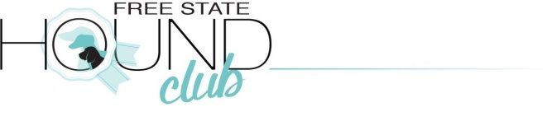
All persons attending the Free State Hound Kennel Club’s Championship show on the 13th of March 2021, are required to complete and sign this disclaimer, which must be lodged at the entrance to the show ON ARRIVAL AT THE VENUE
There will be copies available at the show office for exhibitors to complete if they did not bring it allong. Please note all persons travelling in the same vehicle must complete this form.
Admission may only be granted to persons who have completed and signed this document and submitted it to the organisers on arrival at the venue
DISCLAIMER
I, ____________________________, declare that to the best of knowledge, I do not have COVID-19, and has not been in contact with any person suffering from COVID-19 during the last 10 days leading up to the show,and in the event that I experience symptoms prior to the event, I shall not attend
I understand and accept that all spectators, officials, handlers & dogs attend & compete at this event entirely at their own risk.
While all necessary precautions will be taken, neither KUSA, nor THE FREE STATE HOUND KENNEL CLUB, at Frankfort Sporting gounds, Church Street Frankfort, nor any of their officials or organisers will be held responsible or liable for the safety and health of dogs, handlers, exhibitors, spectators or any other attendees at this event.
I have read and agree to abide by the Official Government Regulations issued in respect of COVID-19, as well as the safety protocols published by the organisersand agree to adhere to all guidlines, including but not limited to:
- Wearing a mask covering both nose and mouth at all times,except when running while handling a dog during competition
- Observing social distance by maintainig a distance of at least 1.5 metres between myself and others, wwith whom I do not live,whenever feasible
- Cleaning and sanitising my own equipment and area regularly
- Sanitising my hands on a regular basis
- Complying with any other instructions issued by COVID-19 Compliance Officer at this event
- I further understand that the right of admission is reserved and the organisers have the right to request that I leave the venue at any time if I do not comply guidlines for COVID-19, with which request I shall summarily comply.

__________________________________ __________________________________
Full Name ID Number
_________________________________ _______________________________
Signature Date
****** If applicant is a minor – under 18 years – legal Guardian to sign and Provide ID number ***
__________________________________ _______________________________
Full name of Guardian ID Number of Guardian

____________________________________ __________________________________
Signature of Guardian Date

