THE WORKING AND HERDING BREEDS CLUB OF THE CAPE

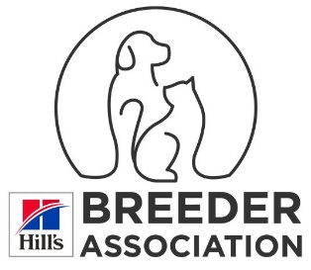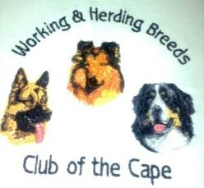

**THIRTY-SEVENTH CHAMPIONSHIP SHOW**

**Fri, 22ndd October 2021**

# AT THE STELLENBOSCH RIDING CLUB, STELLENBOSCH R 44

***PLEASE NOTE: Only Members of the Kennel Union shall be entitled to enter dogs in their registered ownership in any Championship Dog Show licenced by the Kennel Union.***

|  |  |
| --- | --- |
| **JUDGE :**    **Entries Close** | ***HERDING GROUP*** ***Mr K Hull 9H00***  **Best PUPPY / JUNIOR / VET / – BEST IN SHOW** ***Mr K Hull***  ***WORKING GROUP Mrs L Miller-Pio 9H00***  **8th October 2021.** Faxed or e-mailed entries must be accompanied by proof of payment..  Money deposited will not be refunded. ***Please use the latest official KUSA Show entry form dated 1.1.2019*** |
| **Please note**  **Entry Fees:**  **Catalogues:** | **PLEASE ADD R 20-00 TO CASH PAYMENTS to cover BANK CHARGES. Thank you.**  **PLEASE USE SURNAME AS REFERENCE ON PAYMENT**  **Non-Members R 130-00** per dog    **Members R 110-00** per dog    ***MEMBERSHIP: - R20.00 PER FAMILY AND R15.00 PER SINGLE MEMBER***  **R 25-00** (Group only) to be ordered and paid for with entries |
| **Entries & Enquiries:** | Hon Secretary, Mrs Hella Fricke: Tel: 076 170 7218  P O Box 59, Koelenhof 7605 **e-mail**: whbc@telkomsa.net |
| **Banking details:** | ABSA , Santyger, Branch Code 632005, Savings Account No: 909 484 0695 |
| **Show Manager/Officials:** | Mr. R Koning (Show Manager/Chairman), Mrs D Hull (Vice Chairman),  Mrs L Raubenheimer (Hon Treasurer)  **CORONA VIRUS PROTOCOL OFFICER Mrs D Hull**  **DEPUTY PROTOCOL OFFICER Mr R Koning** |
| **Vet on call:** | Dr Jackson |
| **KUSA Rep** | Mrs D E Powell |
| **Breed Classes:**  **PLEASE NOTE** | **Minor** **Puppy** (6-9 months) **Puppy** (9-12 months**) Junior**  (12 – 18 months) **Graduate** (18 – 24 months) **S A Bred Veteran** (7 years +)  **Open Champions**    **See attached COVID protocols which will be strictly applied at this Show** |
| **Judging order GROUP/BIS** | **Breeds will be judged in alphabetical order as per Appendix A of Schedule 2 of the KUSA Constitution**    **BEST PUPPY / BEST JUNIOR / BEST VET / GROUP - BEST IN SHOW** |

**BITCHES IN SEASON are allowed in the BREED Ring**

All Exhibitors/Handlers are personally responsible for the control of their dogs at all times and shall be personally liable for any claims which may be made in respect of injuries which may arise or be caused by their dogs

SPONSORED BY



Hill’s Pet Nutrition