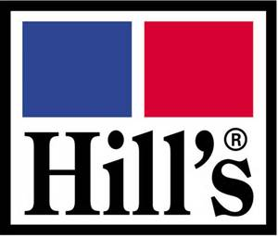

TECKEL CLUB

BREED& CARTING

OPEN SHOW

Date: Sunday 30 January 2022.

Venue: Goldfields Kennel Club, Bottom Field, Boeing Road, Bedfordview.

Time: Entries from 8:30, judging starts at 09:00

Breed Judge: Ms H. Leipsig

Carting Judge: Mrs Y. Taentzer

Show Manager : Mr W. Jansen van Rensburg

Enquiries: Tracey Dorrington Tel: 072 174-0021 ; Wendy Davies Tel: 072 440-8322
Breed Classes: Baby Puppy 4-6 months, Minor Puppy 6-9 months, Puppy 9-12 months, Junior 12-18
months, Graduate 18-24 months, Veterans 7years and older, Open – Any age, Neuter,
Champions

Entry Fees : Breed R 50.00 per class for first two dogs, R 40.00 for all subsequent dogs
CartingR 50.00 per dog per class

BEST IN SHOW ORDER OF JUDGING:
BEST IN SHOW, BEST PUPPY,
BESTJUNIOR, BEST VETERAN, BEST BABY PUPPY & BEST NEUTER

This show is held under the rules of the Kennel Union of Southern Africa.
All Exhibitors/Handlers are personally responsible for the control of their dogs at all times and shall be personally liable for any claims which may be made in respect of injuries which may arise or be caused by their dogs.

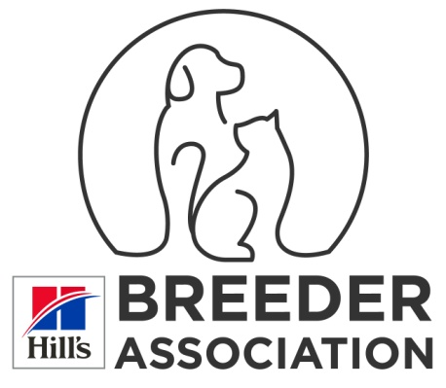
RIGHT OF ADMISSION RESERVED

COVID-19 Protocols & Procedures will be observed at this event
• A maximum of 2000 people will be allowed at the venue at any one time if held outdoors, or 750
attendees if held indoors.
• All persons attending this event must wear a reusable cloth or sponge face mask, or a disposable
surgical mask, except when running while handling a dog in competition. Face shields only are not
legal. Any person not wearing a mask will be requested to leave the venue.
• All attendees must observe social distancing and, whenever feasible, maintain a distance of at least
1.5 metres between themselves and others with whom they don’t cohabit.
• Sanitiser will be available at the Organisers’ Office, on all Judges’ tables, at ring entrances and in the
toilet areas.
• Please note that by entering and/or attending this event, participants are agreeing to comply with
any instructions issued by the COVID-19 Compliance Officers
• The organisers have the right to request any person who refuses to comply with a request or
instruction to leave the venue.
• Any person found to be non-compliant may also be liable for disciplinary action under Schedule 1 of
the KUSA Constitution.
The above Protocols and Procedures are subject to immediate change in the event of either the Alert
Level, or the Government Regulations pertaining to COVID-19, being varied prior to this event.

THE COVID-19 COMPLIANCE OFFICERS AT THIS EVENT ARE:
COVID-19 Compliance Officer: Mrs CA Miscia, 082 794 3777, #164180
Deputy COVID-19 Compliance Officer: Ms TL Dorrington 072 174 0021

